Pavement Drainage and Storm Sewer

Overview
In this chapter, guidelines are given for evaluating and designing storm drainage of the minor system. The minor drainage system is typically designed for more frequent storms with moderate flows and generally consists of storm drains and related appurtenances, such as inlets, curbs, and gutters.
Runoff from large areas draining toward a roadway should be intercepted prior to reaching the roadway whenever possible. This applies to drainage from residential neighborhoods, commercial or industrial property, long cut slopes, side streets, and other areas along the pavement. If extraneous drainage cannot be intercepted prior to reaching the roadway, it should be included in the pavement drainage design.
Additional design procedures for pavement drainage and storm sewer can be found in the most recent edition of the Hydraulic Engineering Circular No. 22: Urban Drainage Design Manual (HEC 22).

Pavement Drainage Criteria

Return Period
Since it generally is not economically feasible to design the minor system for the maximum runoff that a watershed is capable of producing, design storm frequency criteria must be established. The design storm frequency criteria for pavement drainage for the minor storm is 5 years for residential and 10 years for downtown, commercial, and industrial areas. Pavement drainage design storm frequency for the major storm is 100 years.

Spread and Cross Street Flow
Allowable maximum street encroachment by stormwater runoff is listed in Table 3-1 and Table 3-2. All freeways or expressways shall be designed per the NDOT Drainage Design and Erosion Control Manual.
Table 3-1. Allowable Maximum Street Encroachment
Street Classification | Minor Storm¹ | Major Storm²
Local | No curb overtopping. | Runoff shall be contained within the right-of-way or drainage easements. The maximum allowable depth at the gutter is 18 inches.
Collector | No curb overtopping, spread may not cover crown. | Runoff shall be contained within the right-of-way or drainage easements. The maximum allowable depth at the gutter is 18 inches.
Arterial | No curb overtopping, spread shall leave at least one lane free of water in each direction. | Runoff shall be contained within the right-of-way or drainage easements. The maximum allowable depth at the crown is 6 inches. The maximum allowable depth at the gutter is 18 inches.
¹ Minor Storm: 5 year for residential and 10 year for downtown/industrial/commercial.
² Major Storm: 100 year.
Table 3-2. Allowable Maximum Cross-Street Flow
Street Classification | Minor Storm¹ | Major Storm²
Local | 6-inch depth at crown. Where cross-pans allowed, depth shall not exceed 6 inches. | Runoff shall be contained within the right-of-way or drainage easements. The maximum allowable depth at the gutter is 18 inches.
Collector | Where cross-pans allowed, depth shall not exceed 6 inches. | Runoff shall be contained within the right- of-way or drainage easements. The maximum allowable depth at the gutter is 18 inches.
Arterial | None | Runoff shall be contained within the right-of-way or drainage easements. The maximum allowable depth at the crown is 6 inches. The maximum allowable depth at the gutter is 18 inches.
¹ Minor Storm: 5 year for residential and 10 year for downtown/industrial/commercial.
² Major Storm: 100 year.

Longitudinal Grade
To provide for drainage, to avoid unacceptable stormwater spread into traffic lanes, and to avoid ponding in the gutter, curb and gutter grades shall not be less than 0.3 percent, except near sags in the roadway profile.

Cross Slope
Roadway cross slopes shall be determined by the City’s standard roadway sections.

Curb and Gutter
Curb and gutter dimensions shall be determined by the City’s standard details.

Gutter Flow Calculations
Gutter flow capacities should be calculated using the modified form of Manning’s equation shown below and using Manning’s n values from Table 3-3.
$$Q=\left({0.56}/n\right) S_{x}^{5/3} S^{1/2} T^{8/3}$$
(Use when width of spread (T) is known.)
Or
$Q=0.56(z/n) S^{1/2} d^{8/3}$
(Use when depth (d) is known.)
Where: $Q=Gutter Flow Rate, cfs$
$n=Manning^{'}s Roughness Coefficient$
$S_{x}=Pavement Cross Slope, {ft}/{ft}$
$S=Longitudinal Slope, {ft}/{ft}$
$T=Width of Flow or Spread, ft$
$z=Reciprocal of Pavment Cross Slope, 1/{S_{x}}$
$d=Depth of Flow, ft$
Table 3-3. Manning’s n Values for Street and Pavement Gutters
Type of Gutter or Pavement |  | Manning’s n
Concrete Gutter, Troweled Finish |  | 0.012
Asphalt Pavement | Smooth Texture | 0.013
 | Rough Texture | 0.016
Concrete Gutter with Asphalt Pavement | Smooth Texture | 0.013
 | Rough Texture | 0.015
Concrete Pavement | Float Finish | 0.014
 | Broom Finish | 0.016
For gutters with small slopes, where sediment may accumulate, increase above values of n by: |  | 0.002

Stormwater Inlets

Overview
Stormwater inlets should be placed as necessary to limit the depth or spread of runoff in the roadway to allowable limits as previously described. Inlets should generally be placed at the following locations:
- At low points or sags in the gutter grade
- Upgrade of intersections, median breaks, and pedestrian crosswalks
- Upgrade of locations where cross slope reverses
- Upgrade of bridges
- Where gutter flow reaches allowable maximum spread widths
In sag locations on collector or arterial streets, flanking inlets should be placed upstream and to both sides of the inlet at the low point of the sag. Flanking inlets should be placed 0.2 vertical feet higher than the inlet at the low point or located according to HEC 22.

Grate Inlets
Grate inlets consist of an opening covered by one or more grates and may be used for parking lots, area drains, or similar scenarios. Grate inlets are generally not used on public streets.

Grate Inlets on a Continuous Grade
Generally, grate inlets placed on a continuous grade have lower efficiencies than curb inlets placed in a similar configuration; therefore, grate inlets are not recommended to be placed on a continuous grade along a public street. In situations where the installation of a grate inlet on a continuous grade is warranted, the interception efficiency and capacity can be calculated using the procedures found in HEC 22.

Grate Inlets in Sag Locations
A grate inlet in a sag location operates as a weir up to a certain depth, depending on the size of the grate, and as an orifice at greater depths. Grates of larger dimension will operate as weirs to greater depths than smaller grates. Some assumption must be made regarding the nature of clogging of a grate inlet in a sump condition to compute the capacity of a partially clogged grate. The clogging factor (C_{f}) is used to approximate the effects of clogging on a grate inlet.
The capacity of a grate inlet operating as a weir is:
$$Q_{i}=C_{f}C_{w}Pd^{1.5}$$
Where: $Q_{i}=Flow Capacity of an Inlet, cfs$
$C_{f}=Clogging Factor, 0.5 is Recommended$
$C_{w}=Weir Coefficient Equal to 3.0$
$P=Perimeter of Grate Excluding the Side Against the Curb, ft$
$d=Average Depth of Water Above the Top of the Grate, ft$
The capacity of a grate inlet operating as an orifice is:
$$Q_{i}={C_{f}C}_{o}A_{cl}{\left(2gd\right)}^{0.5}$$
Where: $C_{o}=Orifice Coefficient Equal to 0.67$
$A_{cl}=Clear Opening Area of the Grate, sq ft$
$g=Gravitational Constant Equal to 32.2 {ft}/{s^{2}}$

Curb Inlets
Curb inlets consist of a vertical opening in the curb covered by a top slab and are typically used to drain public streets.

Curb Inlets on a Continuous Grade
The length of the curb inlet required for total interception of gutter flow on a pavement section with a uniform cross slope is expressed by:
$$L_{T}=KQ^{0.42}S^{0.3}{\left[1/{\left(nS_{x}\right)}\right]}^{0.6}$$
Where: $L_{T}=Curb Inlet Length Required to Intercept 100\% of the Gutter Flow, ft$
$K=0.6$
$Q=Gutter Flow, {cu ft}/{sec}$
$S=Longitudinal Slope, {ft}/{ft}$
$n=Manning^{'}s Roughness Coefficient$
$S_{x}=Pavement Cross Slope, {ft}/{ft}$
The efficiency of curb inlets shorter than the length required for total interception is expressed by:
$$E=1-{\left[1-\left(L/{L_{T}}\right)\right]}^{1.8}$$
Where: $E=Capture Efficiency of a Curb Inlet$
$L=Curb Inlet Length, ft$

The length of inlet required for total interception by depressed curb inlets or curb openings in depressed gutter sections can be found by the use of an equivalent cross slope, S_{e}, in place of S_{x}. S_{e} is expressed by:
$$S_{e}=S_{x}+S_{w}^{'}E_{o}$$
Where: $S_{e}=Equivalent Cross Slope, ft/ft$
$S_{w}^{'}=Cross Slope of the Gutter Measured from the$
$Cross Slope of the Pavement, ft/ft$
$E_{o}=Ratio of Flow in the Depressed Section to the Total Gutter Flow$
$Determined by the Gutter Configuration Upstream of the Inlet$
Figure 3-1. Depressed Curb Inlet
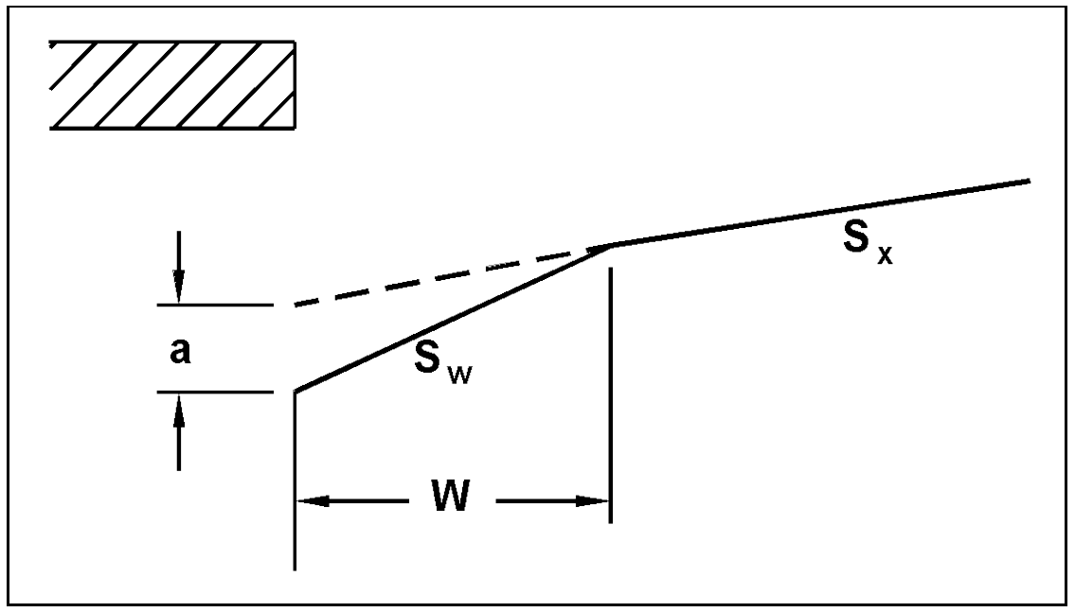
The cross slope of the depressed gutter measured from the cross slope of the pavement is expressed by:
$$S_{w}^{'}=a/W$$
Where: $a=Gutter Depression, ft$
$W=Width of the Depressed Gutter, ft$
The ratio of flow in the depressed section to the total gutter flow determined by the gutter configuration upstream of the inlet is expressed by:
$$E_{o}={Q_{w}}/Q=1-{\left(1-W/T\right)}^{2.67}$$
Where: $Q_{w}=Flow in Width of Depressed Gutter, W, cfs$
$Q=Total Gutter Flow, cfs$
$T=Spread of Total Gutter Flow, ft$

Curb Inlets in Sag Locations
The capacity of a curb inlet in a sag depends on water depth at the curb, the curb opening length, and the height of the curb opening, including any depression. The inlet operates as a weir to depths equal to the curb opening height and as an orifice at depths greater than 1.4 times the opening height. At depths between 1.0 and 1.4 times the opening height, flow is in a transition stage.
The equation for interception capacity of a non-depressed curb inlet operating as a weir is shown below. The depth limitation for operation as a weir is the depth at the curb must be less than or equal to the height of the curb opening ($d≤h$).
$$Q_{i}=C_{w}Ld^{1.5}$$
Where: $Q_{i}=Interception Capacity of an Inlet, cfs$
$C_{w}=Weir Coefficient Equal to 3.0$
$L=Curb Inlet Length, ft$
$d=Depth at Curb Measured from the Normal Cross Slope, ft$
$$(d=TS_{x})$$
At curb inlet lengths greater than 12 feet, the equation for non-depressed inlet (above) produces intercepted flows that exceed the values for the equation for depressed inlets (below). Since depressed inlets will perform at least as well as non-depressed inlets of the same length, the equation for non-depressed curb inlets (above) should be used for all curb inlets having lengths greater than 12 feet.
The equation for the interception capacity of a depressed curb inlet operating as a weir is shown below. The depth limitation for operation as a weir is the depth at the curb must be less than or equal to the height of the curb opening plus the depth of the depression ($d≤h+a$).
$$Q_{i}=C_{w}\left(L+1.8W\right)d^{1.5}$$
Where: $C_{w}=Weir Coefficient Equal to 2.3$
$W=Width of the Depressed Gutter, ft$
Curb inlets operate as orifices at depths greater than approximately 1.4 times the opening height. The equation for the interception capacity of a curb inlet acting as an orifice is shown below. This equation is applicable to depressed and non-depressed curb inlets. The depth at the inlet includes any gutter depression.
$$Q_{i}=C_{o}hL{\left(2gd_{o}\right)}^{0.5}$$
Where: $C_{o}=Orifice Coefficient Equal to 0.67$
$h=Height of Curb Opening, ft$
$g=Gravitational Constant Equal to 32.2 {ft}/{s^{2}}$
$d_{o}=Effective Head on the Center of the Orifice Throat, ft$
Figure 3-2. Curb Inlet Opening Configurations
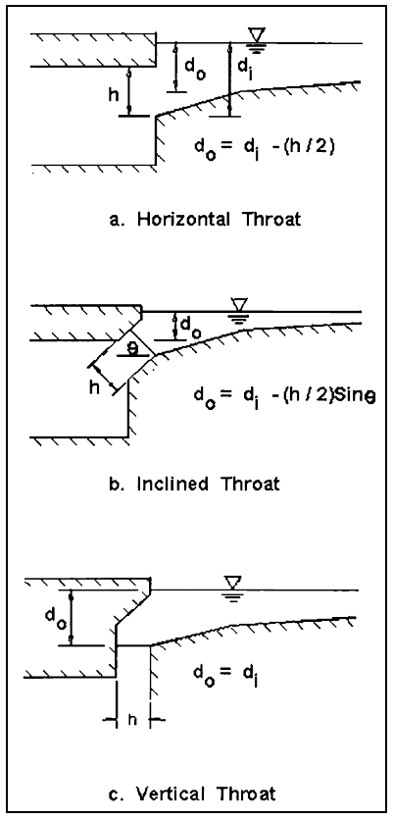

Storm Sewer

Overview
The installation of storm sewer systems is required when the other parts of the minor system (i.e., curb, gutter, and roadside ditches) no longer have capacity for additional runoff, so that spread widths and flow depths exceed requirements previously presented. It should be recognized that the rate of discharge to be carried by any section of storm sewer is not necessarily the sum of the inlet design discharge rates of all inlets above that section of pipe, but as a general rule is somewhat less than this total. The time of concentration is most influential, and as the time of concentration grows larger, the proper rainfall intensity to be used in the design grows smaller.

Design Criteria
Hydraulic design of storm sewers shall be in accordance with the following:

Material and Capacity
- All storm sewer pipe shall have smooth interior walls.
- All storm sewer pipe shall be reinforced concrete pipe (RCP), high density polyethylene pipe – smooth interior (HDPE-SI), or polyvinyl chloride pipe (PVC). Reinforced concrete pipe shall have a pipe class determined according to the actual depth of cover over the pipe. Pipe joints and construction shall conform with the requirements of the City standard specifications.
- Storm sewers shall be designed using a Manning’s n value of 0.012. See Chapter Five for Manning’s n values of pipe materials other than RCP to evaluate the hydraulic capacity of existing systems.
- The minimum pipe size for storm sewer is 15 inches.
- Storm sewers should be designed to flow full at the design runoff for the minor storm. To prevent silt accumulation, a full flow velocity of 3 feet per second should be maintained in the storm sewer. The full flow velocity should not exceed 20 feet per second.
- The hydraulic grade line shall be 0.75 feet below the intake lip of any affected inlet, any manhole cover, or the flow line of the highest pipe of any entering non-pressurized system.
- The energy grade line shall not rise above the intake lip of any affected inlet, any manhole cover, or the flow line of any such entering non-pressurized system.
- Storm sewer pipes will remain the same size or increase in size going downstream within a system.

Alignment and Depth of Cover
- Storm sewers should be constructed on a straight (tangent) alignment between manholes and inlets. Storm sewers should not be constructed on curves.
- Pipe crowns shall be matched at manholes and inlets unless a drop manhole is being used to control the velocity.
- The maximum spacing of access points to the storm sewer shall not exceed 500 feet.
- The minimum physical pipe slope shall be 0.5 percent. Flatter slopes, especially for large‐diameter storm sewer, may be used in design if scour velocity is maintained and if approved by the City.
- The desired depth of cover above a storm sewer pipe shall be 2 to 3 feet, with 1.5 feet being the absolute minimum. Cover greater than 3 feet should generally be avoided due to the possibility of the storm sewer blocking access of sanitary sewer service lines.
- Storm sewers should be laid a minimum of 10 feet horizontally from any existing or proposed water main (measured edge to edge). In cases where it is not practical to maintain a 10-foot separation, the Nebraska Department of Health and Human Services (NDHHS) may allow installation of the sewer closer to the water main, provided that the sewer is laid in a separate trench or on an undisturbed earth shelf located on one side of the water main or at such an elevation that the bottom of the sewer is at least 18 inches above the top of the water main.
- When crossing a water main, the edge of the storm sewer shall be a minimum vertical distance of 18 inches from the outside edge of the water main. This shall be the case whether the sewer is above or below the water main. At crossings, one full length of water pipe shall be located so that both joints will be at least 10 feet from the sewer, or 20 feet of the water main shall be enclosed by casing centered on the sewer.
- The NDHHS must specifically approve any variance from the requirements of these instructions when it is impossible to obtain the specified separation distances.

Capacity Calculations
The most widely used formula for determining the hydraulic capacity of storm sewer pipes is Manning’s equation expressed by:
$$V={\left(1.486R^{2/3}S^{1/2}\right)}/n$$
Where: $V=Average Velocity of Flow, ft/s$
$R=Hydraulic Radius, ft$
$=The Area of Flow Divided By the Wetted Perimeter (A/{WP})$
$S=The Slope of the Hydraulic Grade Line, {ft}/{ft}$
$n=Manning^{'}s Roughness Coefficient$
In terms of discharge, Manning’s equation becomes:
$$Q={\left(1.486AR^{2/3}S^{1/2}\right)}/n$$
$Q=Rate of Flow, cfs$
$A=Cross Sectional Area of Flow, sq ft$
For pipes flowing full, the above equations become:
$$V={\left(0.590D^{2/3}S^{1/2}\right)}/n$$
$$Q={\left(0.463D^{8/3}S^{1/2}\right)}/n$$
Where: $D=Diameter of Pipe, ft$

Energy Grade Line and Hydraulic Grade Line
The energy grade line (EGL) is an imaginary line that represents the total energy along a channel or conduit carrying water. Total energy includes elevation (potential) head, velocity head, and pressure head. The calculation of the EGL for the full length of the system is critical to the evaluation of a storm sewer. To develop the EGL, it is necessary to calculate all of the losses through the system. The energy equation states that the energy head at any cross section must equal that in any other downstream section plus the intervening losses. The intervening losses are typically classified as either friction losses or form losses. Knowledge of the location of the EGL is critical to understanding and calculating the location of the hydraulic grade line (HGL).
The HGL is a line coinciding with the level of flowing water at any point along an open channel. In closed conduits flowing under pressure, the HGL is the level to which water would rise in a vertical tube at any point along the pipe. The HGL is determined by subtracting the velocity head (V²/2g) from the EGL. The HGL is used to aid the designer in determining the acceptability of a proposed storm drainage system by establishing the elevation to which water will rise when the system is operating under design conditions.
The methodology in HEC 22 should be used for the calculation of the energy losses, the energy grade line, and the hydraulic grade line for a storm sewer system.

Manholes
Manholes provide access to storm drains for inspection and cleanout and are used for changing direction, grade, or convergence. Care should be taken to ensure the diameter of the manhole is adequate to accommodate all entering and exiting pipes. The designer should use supplier’s recommendations and lay out the geometrics of the pipes and manhole to verify the diameter is adequate. The crowns of all storm sewer pipes entering and leaving a manhole shall be at the same elevation. Manholes should generally be placed at the following locations:
- Convergence of two or more storm sewers
- Intermediate points along tangent sections
- Change in pipe size
- Change in pipe alignment
- Change in pipe grade

References
- City of Brookings, South Dakota, 2006. Storm Drainage Design and Technical Criteria Manual.
- City of Lincoln Public Works and Utilities Department, 2000. Drainage Criteria Manual.
- City of Omaha Environmental Quality Control Division, 2014. Omaha Regional Stormwater Design Manual.
- Federal Highway Administration, 2009. Hydraulic Engineering Circular No. 22, Third Edition, Urban Drainage Design Manual.
- Nebraska Department of Transportation, 2006. Drainage Design and Erosion Control Manual.

