EROSION AND SEDIMENT CONTROL

Purpose and Scope
This chapter provides criteria for measures that should be taken for construction site stormwater discharges to meet the requirements of the Federal Clean Water Act, the Nebraska Environmental Protection Act, and City ordinances adopted to meet state and federal requirements. Through implementation of the guidelines in this chapter, including development of a Stormwater Pollution Prevention Plan (SWPPP), adverse water quality impacts associated with erosion and sedimentation can be prevented or minimized.
Requirements for Construction Activity SWPPPs are in Section 8.2. The remainder of this chapter embodies a range of guidelines, criteria, and alternatives for meeting the preparation and implementation requirements of the SWPPP. Section 8.3 covers SWPPP Design Considerations and Best Management Practice (BMP) selection. Section 8.4 addresses Erosion and Sediment Control BMP, and Section 8.5 addresses Good Housekeeping BMPs.
The guidelines in this section are consistent with National Pollutant Discharge Elimination System (NPDES) General Permit Number NER160000 for Stormwater Discharges from Construction Sites to Waters of the State of Nebraska (issued September 30, 2016).

General Information for SWPPPs
A SWPPP is more than just a sediment and erosion control plan. It is a comprehensive, written document that describes the pollution prevention practices and activities that will be used during each phase of construction. It describes the site and each major phase of the planned activity, the roles and responsibilities of contractors, and the inspection schedules and logs. It is also a place to document changes and modifications to the construction plans and associated stormwater pollution prevention activities.
1. The SWPPP must be implemented either prior to or concurrent with the initiation of construction activity. SWPPP activities must be maintained throughout the period construction activities are ongoing until final site stabilization is achieved. A current and updated copy of the SWPPP must be retained at the construction site where the construction is being performed or other nearby location easily accessible during normal business hours. Persons and/or subcontractors responsible for carrying out duties pursuant to the SWPPP must be properly trained and informed of their responsibilities.
2. The SWPPP shall be dynamic. If deficiencies in the plan arise during the project or differing site conditions warrant, the applicant must implement effective corrective actions that may require modification of the SWPPP.
3. The City may require modification of the SWPPP:
a. If it is not effective in minimizing erosion or the release of stormwater pollutants from the site.
b. If more effective procedures are available and practical.
c. If previous experience has shown the control methods specified have proven to be inadequate in similar circumstances.
d. To meet basin specific NDEE water quality requirements or goals.
e. To correspond to changes in the development plan for the site.
f. In the event of repetitive failure to adequately maintain practices.

Common SWPPP Objectives
For a SWPPP to be effective, it must be developed in the project planning stage and effectively applied during construction. In most cases, the most practical method of controlling erosion and the associated production and transport of sediment includes a combination of limited time of soil exposure and judicious selection of erosion control practices and sediment trapping facilities. The SWPPP should be prepared to meet the following objectives:
1. Minimize the extent and the duration of soil exposure and minimize offsite impacts to waterbodies and adjoining properties. The duration of soil exposure can be minimized through construction phasing, prompt revegetation and mulching. Grading should be completed as soon as possible and followed by permanent revegetation. As cut slopes are made and as fill slopes are brought up to grade, these areas should be revegetated. Minimizing grading of large or critical areas during the seasons of maximum erosion potential (April through September) reduces the risk of erosion.
2. Apply erosion control practices to prevent excessive sediment production. Keep soil covered to the extent practicable with temporary or permanent vegetation or mulch. Special grading methods such as roughening a slope on the contour or tracking with a cleated dozer may be used. Other practices include diversion structures to divert surface runoff from exposed soils and grade stabilization structures to control surface water. “Gross” erosion in the form of gullies must be prevented by these water control devices.
3. Apply perimeter sediment control practices to protect the disturbed area from offsite runoff and to prevent sedimentation damage to areas below the construction site. This principle relates to using practices that effectively isolate the construction site from surrounding properties and especially to controlling sediment once it is produced and preventing its transport from the site. Generally, sediment can be retained by two methods: (a) filtering runoff as it flows through an area and (b) impounding the sediment-laden runoff for a period of time so that the soil particles settle out. Diversions, dikes, sediment traps, vegetative and structural sediment control measures can be used to control sediment. These measures may be temporary or permanent, depending on whether they will remain in use after construction is complete. The best way to control sediment, however, is to prevent erosion.
4. Keep runoff velocities low and retain runoff on the site. The removal of existing vegetative cover and the resulting increase in impermeable surface area during construction will increase both the volume and velocity of runoff. These increases must be considered when providing for erosion control. Keeping slope lengths short and gradients low and preserving natural vegetative cover can keep stormwater velocities low and limit erosion hazards. Runoff from the development should be safely conveyed to a stable outlet using storm drains, diversions, stable waterways, or similar measures. Conveyance systems should be designed to withstand the velocities of projected peak discharges. These facilities should be operational as soon as possible.
5. Stabilize disturbed areas as soon as practicable, but in no case more than 14 days after final grade has been attained. Permanent structures, temporary or permanent vegetation, mulch, stabilizing emulsions, or a combination of these measures should be used as quickly as possible after the land is disturbed. Temporary vegetation and mulches and other control materials can be most effective when it is not practical to establish permanent vegetation or until permanent vegetation is established. Such temporary measures should be used as soon as practicable, but in no case more than 14 days after rough grading is completed if a delay is anticipated in obtaining finished grade. The finished slope of a cut or fill should be designed to be stable and easily maintained. Stabilize roadways, parking areas, and paved areas with a gravel sub-base whenever possible.
6. Implement a thorough maintenance and follow-up program. This last principle is vital to the success of the five other principles. A site cannot be effectively controlled without thorough, periodic checks of the erosion and sediment control practices. These practices must be maintained just as construction equipment must be maintained and material checked and inventoried. An example of applying this principle would be to start a routine “end of day check” to make sure that all control practices are working properly.

SWPPP Requirements for Construction Activity
Construction activity is the disturbance of one acre or more of land area and less than one acre if part of a common plan of development or sale. Prior to construction activity, a permit application must be submitted in the form of a Notice of Intent (NOI) to the Nebraska Department of Environment and Energy (NDEE) via the state’s online application portal.
Submittals to the City for review should include a Stormwater Pollution Prevention Plan (SWPPP) with the information identified in this chapter, as well as a copy of the NPDES Authorization to Discharge letter from NDEE. The SWPPP must identify the appropriate Best Management Practices (BMPs) to be implemented to control erosion, sedimentation, and pollutants, such as those described in Section 8.3.
Prior to construction activity for sites less than one acre that are part of a common plan of development or sale (i.e., residential lots), an individual lot notice of intent (INOI) permit must be submitted to the City through the building permit process.
The SWPPP must be prepared and signed by a qualified individual as defined in the NDEE Construction Stormwater General Permit. Review approval or comments are scheduled to be reviewed within seven (7) calendar days after receipt of application by the City. Prior to actual initiation of the construction activity, the applicant must have received approval from both the City and NDEE.
When responsibility for stormwater discharges at a construction site changes from one entity to another, the permittee shall complete a new Construction Stormwater (CSW) NOI to NDEE via the state’s online application portal. Any change in NPDES permit status should be provided to the City.
Once the construction is complete in accordance with the design standards, and the site has achieved Final Stabilization, the applicant must submit to NDEE a Notice of Termination. Final Stabilization is a condition where all soil disturbing activities at the site have been completed and a uniform perennial vegetative cover with a minimum density of 70 percent of the native background vegetative cover has been established on all non-impervious surfaces and areas not covered by permanent structures unless equivalent permanent stabilization measures have been employed (i.e., riprap, gabions, or geotextiles).
The State permit will expire with the approved Notice of Termination or with the expiration of the State of Nebraska Construction General Permit. Permits that expired with the expiration of the State permit can be extended up to one year with NDEE approval. If not extended or upon end of extension, a new permit with current information must be requested that meets current standards.
In preparing the SWPPP, individuals should review this section and those that follow. Specifically, those preparing plans should be familiar with SWPPP requirements (Section 8.2), as well as the selection and design of BMPs, and the fundamentals of the erosion process.

Summary of Required SWPPP Items for Construction Activity
The following is a summary of required SWPPP items for Construction Activity to be prepared in accordance with Section 8.2 and 8.3 of this chapter.

Narrative
- Project Description – Briefly describes the nature and purpose of the construction activity (i.e., low-density residential, site grading for future commercial development, roadway, etc.), and the area (acres) to be disturbed.
3. Adjacent Areas – Describe neighboring areas such as streams, lakes, residential areas, roads, etc., that might be affected by the construction activity.
4. Offsite Areas – Describe any offsite construction activities that will occur (including borrow sites, waste, or surplus areas, etc.). Will any other areas be disturbed?
5. Soils – Briefly describe the soils on the site giving such information as soil name, erodibility, permeability, depth, texture, and soil structure.
6. Critical Areas – Describe areas on the site that have potentially serious erosion problems (steep slopes, channels, etc.).
7. Construction Sequencing – Briefly describes the anticipated sequence and timing of land disturbance activity.
8. Temporary Erosion and Sediment Controls – Describe the methods that will be used to control erosion and sedimentation on the site during construction, as well as temporary construction stormwater management measures that retain/detain flows or otherwise limit runoff and the discharge of pollutants from exposed areas of the construction site. Controls must meet the minimum specified requirements as found in Section 8.4 of this manual.
9. Permanent Stabilization – Briefly describes, including specifications, how the site will be stabilized after construction is completed.
10. Post-Construction Stormwater Management Measures – Describe all post-construction stormwater management measures that retain/detain flows or otherwise limit runoff and the discharge of pollutants.
11. Controls for Prohibited Discharges – Describe the controls to be used to prevent the following prohibited discharges:
- Wastewater from washout of concrete.
- Wastewater from the washout and cleanout of stucco, paint, form release oils, curing compounds, and other construction materials.
- Fuels, oils, or other pollutants used in vehicle and equipment operation and maintenance.
- Soaps, solvents, or detergents used in vehicle and equipment washing.
- Toxic or hazardous substances from a spill or other release.
12. Offsite Vehicle Tracking Prevention – Describes measures to minimize vehicle tracking of sediments offsite onto paved surfaces and the generation of dust.
13. Non-Sediment Pollutant Management – Describes construction materials, products, and waste materials expected to be stored at the construction site or supporting areas. The description should include controls and storage practices to minimize exposure of the materials to stormwater and stormwater runoff.
14. Spill Prevention and Response Plan – When developing a spill prevention plan, include, at a minimum, the following:
- Note the location of chemical storage areas, storm drains, tributary drainage areas, surface waterbodies on or near the site, and measures to stop spills from leaving the site.
- Specify how to notify the appropriate authorities to request assistance.
- Describe the procedures for immediate cleanup for spills and proper disposal.
- Identify personnel responsible for implementing the plan in the event of a spill.

Site Plan
1. Vicinity Map – A small map locating the site in relation to the surrounding area. Include any landmarks that might assist in locating the site.
2. Indicate North – The direction of north in relation to the site.
3. Limits of Clearing and Grading – Areas that are to be cleared and graded.
4. Existing Contours – The existing contours of the site.
5. Final Contours – Changes to the existing contours, including final drainage patterns.
6. Existing Vegetation – The existing tree lines, grassed areas, or unique vegetation.
7. Existing Drainage Patterns – The dividing lines and the direction of flow for the drainage areas. Include the size (acreage) of each drainage area.
9. Site Development – Show all improvements such as buildings, parking lots, access roads, utility roads, etc.
10. Location of Best Management Practices – The locations of erosion and sediment controls and stormwater management practices used on the site for all phases of construction. For phases prior to final stabilization, show known BMP locations, if possible. While the project is ongoing, amend the SWPPP as needed to reflect current site conditions.
11. Offsite Areas – Identify any offsite construction activities (borrow sites, waste sites, etc.). Show location of erosion controls.
12. Detailed Drawings – Enlarged, dimensioned drawings of such key features as sediment basin drainage structures, energy dissipators, and waterway cross-sections.
13. Detailed Specifications – Specifications for specific items such as seeding mix and planting schedule, filter fabric size, rock gradations, etc.
14. Construction Sequencing – Typically provided by the general contractor prior to project startup, this information provides specifications for the sequence of construction operations describing the relationship between the implementation and maintenance of sediment controls, including permanent and temporary stabilization and the various stages or phases of earth disturbance and construction (i.e., infrastructure, water main flushing).
15. Documentation of Site and Activity Records – The SWPPP must be amended to include dates when major grading activities occur, dates when construction activities temporarily or permanently cease on a portion of the site, and dates when stabilization measures are initiated.
16. Maintenance Program – Describes inspection schedules, spare materials needed, stockpile locations, instructions for sediment removal and disposal, and for repair of damaged structures should be provided. A clear statement defining maintenance responsibility should also be included.

Calculations
1. Calculations and Assumptions – Provide data for design storm used to size pipes, channels, sediment basins, and traps. Include calculations for post-development runoff, as well as any other calculations necessary to support drainage, erosion and sediment, and stormwater management systems.

SWPPP Development – Site Assessment and Planning
The following section describes five critical steps in the SWPPP development process that will help provide a good foundation for the SWPPP.
- Assess the site and proposed project – The SWPPP should describe the undeveloped site and identify land features that can be incorporated into the final plan and natural resources that should be protected. The SWPPP is a legal, binding document and, therefore, must be followed as per design.
a. Visit the site – The people responsible for site design drafting the SWPPP should conduct a thorough walk-through of the entire construction site to assess site-specific conditions such as soil types, drainage patterns, existing vegetation, and topography. Avoid copying SWPPPs from other projects to save time and money. Each construction site is unique, and visiting the site is the only way to create a SWPPP to addresses the unique conditions at that site.
b. Assess existing construction site conditions – Assess the existing conditions at the construction site, including topography, drainage, and soil type. This assessment is the foundation for building the SWPPP and for developing the final site plan. In this assessment, use or create a topographic drawing that:
i. Indicates how stormwater currently drains from the site, and identify the location of discharge points or areas.
ii. Identifies slopes and slope lengths. The topographic features of the site are a major factor affecting erosion from the site.
iii. Identifies soil type(s) and any highly erodible soils and the soil’s infiltration capacity.
iv. Identifies any past soil contamination at the site.
v. Identifies natural features, including trees, streams, wetlands, slopes, and other features to be protected.
In most cases, the site designer can compile all this information on a digitized drawing that can then be adapted to show the planned construction activity, the phases of construction, and the final site plan.
c. Identify receiving waters, storm drains, and other stormwater conveyance systems – The SWPPP should clearly identify the receiving waters and stormwater systems through which stormwater from the site could flow. If the site’s stormwater flows into a municipal drain system, the plan designer will need to determine the ultimate destination of that system’s discharge. If the site’s stormwater runs off to areas not connected to the storm drain system, the designer should consider the land’s topography and then identify the waterbodies that it could reach.
d. Describe the construction project – The SWPPP should briefly describe and identify the construction activity, including:
i. Project type or function (i.e., low-density residential, industrial center, street widening)
ii. Project location, including latitude and longitude, and section-township-range
iii. Estimated project start and end dates
iv. Sequence and timing of activities that will disturb soils at the site
v. Size of the project
vi. Estimated total area expected to be disturbed by excavation, grading, or other construction activities, including dedicated offsite borrow and fill areas
vii. Soil types
viii. Location of other potential sources of stormwater contamination, such as asphalt and concrete plants, paint and concrete washout areas, etc.
e. Identify pollutants and pollution sources – Identify the pollutants and sources that are likely to be found on the site. Sediment is the main pollution of concern, but other pollutants may be found, usually in substantially smaller amounts, in stormwater runoff from construction sites. These can include nutrients, heavy metals, organic compounds, pesticides, oil and grease, bacteria and viruses, trash and debris, and other chemicals (i.e., fuel storage and/or refueling location). After identifying the pollutants and sources, be as specific as possible in the SWPPP about the BMPs that will be used to address them.
2. Identify approaches to protect natural resources – The SWPPP should describe methods to be used to protect and preserve any streams, wetlands, ponds, or other waterbodies that are on the property or immediately adjoining it. Riparian areas around headwater streams are especially important to the overall health of the entire river system. Contact the Nebraska Department of Environment and Energy to determine if any impaired waters designation has been placed on any adjacent streams, rivers, or waterbodies. A permittee might be subject to additional requirements to protect these waterbodies.
Wetland areas, including bogs marshes, and sloughs, may be found in areas adjacent to rivers, streams, and lakes but may also be found in isolated places far from other surface waters. Many types of wetlands, especially saline wetlands, are protected under the Clean Water Act, and construction activities in and around these areas may require an additional permit from the U.S. Army Corps of Engineers (i.e., 404 permit). Construction site operators should make every effort to preserve wetlands and must follow local, state, and federal requirements before disturbing them or the areas around them.
3. Assess whether there are endangered plant or animal species in the area – The Federal Endangered Species Act protects endangered and threatened species and their critical habitat areas. In developing the assessment of the site, determine whether listed endangered species are on or near the property. Critical habitat areas are often designated to support the continued existence of listed species. The SWPPP designer will also need to determine whether critical habitat areas have been designated near the project. Contact local offices of the U.S. Fish and Wildlife Service (FWS) or the Nebraska Game and Parks Service.
4. Assess whether there are historic sites that require protection – The National Historic Preservation Act applies to construction activities. As with endangered species, some permits may specifically require the SWPPP designer to assess the potential impact of the stormwater discharges on historic properties. However, whether or not this is listed as a condition for permit coverage, the National Historic Preservation Act and any applicable state laws apply to the project. Contact the State Historic Preservation Officer at the Nebraska State Historical Society for more information.
5. Develop site maps – The final step in the site evaluation process is to document the results of the site assessment and the planned phases of construction activity on a detailed site map or maps. This includes developing site maps showing planned construction activities and stormwater practices for the various major stages of construction, protected areas, natural features, slopes, erodible soils, nearby waterbodies, permanent stormwater controls, and so on. The permittee must keep the SWPPP and the site maps up to date to reflect changes at the site during the construction process.
a. If a marked-up site map is too full to be easily read, the SWPPP designer should date and fold it, put it in the SWPPP for documentation, and start a new one. That way, there is a good hard copy record of what has occurred onsite.

SWPPP Erosion and Sediment Control Requirements
- The applicant must incorporate erosion and sediment control practices into the SWPPP and implement said practices at all locations undergoing construction activity. The erosion and sediment control practices used must consider site-specific variables, including slope, soil types, size of the project, duration of construction activities, proximity of perennial and seasonal streams, and existence of impounded waters downstream of the project. The controls used may vary from site to site, but the controls used must be effective in minimizing erosion and sediment release from the site and in protecting the water quality in the receiving stream or waterbody.
- The existence of downstream lakes or other impounded water increases water quality concerns relative to sediment release. In these instances, more stringent erosion and sediment controls may need to be implemented.
- The applicant must upgrade the erosion and sediment control practices used in the SWPPP and implement additional controls, if existing controls prove inadequate in minimizing erosion and sediment releases, or in protecting the water quality of the receiving stream or waterbody. The applicant must comply with City/State requests to implement additional controls to minimize erosion and sediment releases and to protect receiving waterbodies.
- All SWPPPs submitted for approval must include the following statement: “Unless otherwise indicated, all vegetative and structural erosion and sediment control practices and stormwater management practices will be constructed and maintained according to the minimum standards and specifications of the Drainage Criteria Manual.”
- Stabilize soils properly. Where construction activities have temporarily or permanently ceased, the area must be temporarily or permanently stabilized as soon as practicable, but in no case more than 14 days.
  - All SWPPP plans submitted for approval must include placement of the following statement, “Following soil disturbance, permanent or temporary stabilization must be completed as soon as practicable, but in no case more than 14 days to the surface of all perimeter sediment controls, topsoil stockpiles, and any other disturbed or graded areas on the project site which are not being used for material storage, or on which actual earth moving activities are not being performed.” In subdivisions, this permanent or temporary stabilization must be maintained until development commences on street work or, utility work on individual lots within the subdivision.
  - Temporary measures are necessary when an area of a site is disturbed but where activities in that area are not completed or until permanent BMPs are established. Topsoil stockpiles should also be protected to minimize any erosion from these areas. Silt fence and other sediment control measures are NOT stabilization measures.
  - Temporary cover BMPs include:
  - Mulches
  - Bonded fiber matrices (hydroseeding/mulching)
  - Blankets and mats
  - Use of soil binders/tackifiers
  - Temporary or Cover Crop Seeding, combined with one of the BMPs above to protect the seed from erosion, promoting germination
  - Permanent-cover BMPs include:
    - Permanent seeding and planting
    - Sodding
    - Channel stabilization
    - Vegetative buffer strips
- Protect slopes. Protect all slopes with appropriate erosion controls. Steeper slopes, slopes with highly erodible soils, or long slopes require a more complex combination of controls. Cut and fill slopes must be designed and constructed in a manner that will minimize erosion. Slopes that are found to be eroding excessively within one year of permanent stabilization must be provided with additional slope stabilization measures until the problem is corrected. Examples of BMPs for slope stabilization include:
a. Erosion Control Blankets
b. Turf Reinforcement Mats
c. Bonded Fiber Matrices (hydroseeding/mulching)
d. Wattles (Straw or wood) may also be used as slope interruptions help control erosion on moderate to shallow slopes and should be installed on level contours spaced at 10 to 20-foot intervals. The SWPPP designer can also use diversion dikes and berms to keep stormwater off slopes. Concentrated runoff must not flow down cut or fill slopes unless contained within an adequate temporary or permanent channel, flume or slope drain structure.
- Protect storm drain inlets. Protect all inlets that could receive stormwater from the project until final stabilization of the site has been achieved. If necessary, install protection before soil disturbing activities begin. Install inlet protection before soil-disturbing activities begin, if possible. Maintenance throughout the construction process is important. Storm drain inlet protection should be used not only for storm drains within the active construction project but also for storm drains outside the project area that might receive stormwater discharges from the project. If storm drains on private property could receive stormwater runoff from the project, coordinate with the property owners to ensure proper inlet protection. Inlet protection should be removed during winter conditions (November through March).
- Establish perimeter controls. Maintain natural areas and supplement them with perimeter sediment controls to help stop sediment from leaving the site. Install controls on the downslope perimeter of the project (it is typically not necessary to surround the entire site with silt fence). Sediment barriers can be used to protect stream buffers, riparian areas, wetlands, adjacent public right-of-way, and neighboring private properties. They are effective only in small areas and should not be used in areas of concentrated flow. Sediment basins and traps, perimeter dikes, sediment barriers, and other measures intended to trap sediment must be constructed as a first step in any land-disturbing activity and must be made functional before upslope land disturbance takes place.
- Retain sediment onsite and control dewatering practices. When sediment retention from a larger area is required, consider using a sediment trap or basin. These practices detain sediment-laden runoff for a period, allowing sediment to settle before runoff is discharged. Proper design and maintenance are essential to ensure that these practices are effective.
  - When a site is discharging from basins and impoundments, the site must use outlet structures that withdraw water from the surface, unless infeasible.
  - Where a large sediment basin is not practical, use smaller sediment basins and traps (or both) where feasible. At a minimum, use silt fences, vegetative buffer strips, or equivalent sediment controls for all down-gradient boundaries (and for those side-slope boundaries deemed appropriate for individual site conditions).
- Dewatering practices as used to remove groundwater or accumulated rainwater from excavated areas.
  - Pump muddy water from these areas to a temporary or permanent sedimentation basin or to an area completely enclosed by silt fence or other sediment retention device (i.e., sediment bag) in a flat vegetated area where discharges can infiltrate into the ground.
  - Never discharge muddy water into storm drains, streams, lakes, or wetlands unless sediment has been removed before discharge.
- Establish stabilized construction exits. Vehicles entering or leaving the site have the potential to track significant amounts of sediment onto streets. Identify and clearly mark one or two locations where vehicles will enter and exit the site and focus stabilizing measures at those locations. Construction exits are commonly made with crushed rock. They can be further stabilized using stone pads or concrete. No system is perfect, so sweeping/vacuuming the street regularly completes this BMP.
- Stabilize channels and watercourses. When work in a live watercourse is performed, precautions must be taken to minimize encroachment, control sediment transport and stabilize the work area to the greatest extent possible during construction. Non-erodible material shall be used for the construction of causeways and cofferdams. Earthen fill may be used for these structures if armored by non-erodible cover materials.
  - When live watercourse must be crossed by construction vehicles more than twice in any six-month period, a temporary stream crossing constructed of non-erodible material must be provided. The bed and banks of a watercourse must be stabilized immediately after work in the watercourse is completed.

Good Housekeeping Requirements
Construction projects generate large amounts of building-related waste, which can end up polluting stormwater runoff if not properly managed. The suite of BMPs described in the SWPPP must include pollution prevention practices that are designed to prevent contamination of stormwater from a wide range of materials and wastes at the site. The five principles described in this section are designed to help the SWPPP designer identify the pollution prevention practices that should be described in the SWPPP and implement at the site.
- Provide for waste management.
  - Design proper management procedures and practices to prevent or reduce the discharge of pollutants to stormwater from solid or liquid wastes that will be generated at the site. Practices such as trash disposal, recycling, proper material handling, and cleanup measures can reduce the potential for stormwater runoff to pick up construction site wastes and discharge them to surface waters.
  - Design proper management procedures and practices to prevent or reduce the discharge of pollutants to stormwater from solid or liquid wastes that will be generated at the site. Practices such as trash disposal, recycling, proper material handling, and cleanup measures can reduce the potential for stormwater runoff to pick up construction site wastes and discharge them to surface waters.
- Design proper management procedures and practices to prevent or reduce the discharge of pollutants to stormwater from solid or liquid wastes that will be generated at the site. Practices such as trash disposal, recycling, proper material handling, and cleanup measures can reduce the potential for stormwater runoff to pick up construction site wastes and discharge them to surface waters.
a. Provide well-maintained and properly located toilet facilities. Provide for regular inspections, service, and disposal. Locate portable toilet facilities at least 20 feet away from storm drain inlets and at least 10 feet back from the edge of curb and gutter conveyance systems.
b. Establish proper building material handling and staging areas.
- The SWPPP must include comprehensive handling and management procedures for building materials, especially those that are hazardous and toxic. Paints, solvents, pesticides, fuels and oils, other hazardous materials, or any building materials that have the potential to contaminate stormwater should be stored indoors or under cover whenever possible, or in areas with secondary containment. Secondary containment prevents a spill from spreading across the site and includes dikes, berms, curbing, or other containment methods. Secondary containment systems should also ensure protection of groundwater.
- Designate staging areas for activities such as fueling vehicles, mixing paints, plaster, mortar, etc. Designated staging areas will help monitor the use of materials and to clean up any spills. Training employees and subcontractors is essential to the success of this pollution prevention principle.
- Designate washout areas.
  - All concrete contractors and any subcontractors installing concrete must be required to use designated and marked concrete washout areas on the permitted construction site. Designate specific washout areas and design facilities to handle anticipated washout with water.
  - Washout areas must also be provided for paint and stucco operations. Because washout areas can be a source of pollutants from leaks or spills, it is required that they be located at least 50 yards away from storm drains and watercourses.
  - Regular inspection and maintenance are important for these BMPs. If there is evidence that contractors are dumping materials into drainage facilities or if the washout areas are not being used regularly, the SWPPP designer must consider posting additional signage, relocating the facilities to more convenient locations, or providing training to workers and contractors.
- Establish proper equipment/vehicle fueling and maintenance practices.
  - If offsite fueling and maintenance is not feasible, create an onsite fueling and maintenance area that is clean and dry. Onsite fuel storage tanks must be double walled. The onsite fueling area should have a spill kit, and staff should know how to use it. If possible, conduct vehicle fueling and maintenance activities in a covered area; outdoor vehicle maintenance is a potentially significant source of stormwater pollution. Significant maintenance on vehicles and equipment should be conducted offsite.
  - Clearly designate vehicle/equipment service areas away from drainage facilities and watercourses to prevent stormwater run-on and runoff.
- Develop a Spill Prevention and Response Plan. A Spill Prevention and Response Plan is required for the SWPPP to addresses fueling, maintenance, or storage areas on the site. The plan must comply with the requirements of the City, and Nebraska Department of Environment and Energy (NDEE) Title 126, Chapter 18-Rules and Regulations Pertaining to the Management of Wastes. If the permittee knows or has reason to believe that oil or hazardous substances were released at the facility and could enter Waters of the State or any of the outfall discharges authorized by the permit, it shall be the duty of the present property owner, occupant, or person responsible to notify the City and NDEE of an illicit discharge in the following manner:
  - Hazardous substances. In the event such illicit discharge contains hazardous substances, emergency response agencies shall immediately be notified of the discharge by calling 911. If the Hazardous Material team is needed, 911 will dispatch them to the scene. The Hazmat Team will then make the necessary contact with Local Authorities (Fire Dept, NDEE, etc.) as per the NDEE Title 126 Chapter 18 Rules and Regulations requirement.
  - Nonhazardous substances. In the event such illicit discharge is composed entirely of nonhazardous substances, the City shall be notified in person, by phone, or by email no later than the next business day. Notifications in person or by phone shall be confirmed in writing, addressed, and mailed to the City within three business days of such notice.
  - The plan should clearly identify ways to reduce the chance of spills, stop the source of spills, contain and clean up spills, dispose of materials contaminated by spills, and train personnel responsible for spill prevention and response. The plan should also specify material handling procedures and storage requirements and ensure that clear and concise spill cleanup procedure are provided and posted for areas in which spills may potentially occur.
- When developing a spill prevention plan, include, at a minimum, the following:
  - Note the locations of chemical storage areas, storm drains, tributary drainage areas, surface waterbodies on or near the site, and measures to stop spills from leaving the site.
  - Specify how to notify the appropriate authorities to request assistance.
  - Describe the procedures for immediate cleanup for spills and proper disposal.
  - Identify personnel responsible for implementing the plan in the event of a spill.

Best Management Practice (BMP) Selection
This section provides a decision-making process that can be used to select best management practices (BMPs) to control erosion and sedimentation. It also provides principles for the selection of BMPs for “good housekeeping” on a construction site.

Steps in Selection of Control Measures
1. Identify Control Method(s) – On any construction site, the objective in erosion and sediment control is to prevent offsite sedimentation damage. Three basic methods are used to control sediment transport from construction sites: runoff control, soil stabilization, and sediment control. Controlling erosion (runoff control and soil stabilization) should be the first line of defense. Controlling erosion is effective for small disturbed areas, such as single lots or small areas of a development that do not drain to a sediment trapping facility. Sediment trapping facilities should be used on large developments where mass grading is planned, where it is impossible or impractical to control erosion, and where sediment particles are relatively large. Runoff control and soil stabilization should be used together where soil properties and site topography make the design of sediment trapping facilities impractical. Cost-effective erosion and sediment control typically include a combination of vegetative and structural erosion and sedimentation control measures.
2. Identify Problem Areas – Potential erosion and sediment control problem areas should be identified. Areas where erosion is to be controlled will usually fall into categories of slopes, graded areas, or drainageways. Slopes include graded rights-of-way, stockpile areas, and all cut and fill slopes. Graded areas include all stripped areas other than slopes. Drainageways are areas where concentrations of water flow naturally or artificially and the potential for gully erosion is high.
3. Identify Required Strategy – The third step in erosion and sediment control planning is to develop a strategy that can be taken to resolve the problem. For example, if a cut slope is to be protected from erosion, the strategies may include protecting the ground surface, diverting water from the slope, or shortening the slope. Any combination of the above can be used. If no rainfall except that which falls on the slope has the potential to cause erosion and if the slope is relatively short, protecting the soil surface is often all that is required to resolve the problem.
4. Select Specific Control Measures – The final step in erosion and sediment control planning can be accomplished by selecting and adapting specific control measures that accomplish the strategy developed in Step 3. Items to consider when selecting a final BMP are as follows:
- Timing – Consider the life span of the needed BMP based on the phase of construction. BMP selection will vary during construction phases. A short-term, temporary BMP would be selected for areas where construction activity has stopped for a short period of time, whereas a construction site that is nearing completion will be ready for BMPs suitable for final stabilization.
- Cost – Consider material cost, add-ons, installation, maintenance, preparation costs, and any cleanup for impacts to adjacent properties should they occur.
- Effectiveness – Compare effectiveness of BMPs. Use manufacturer specifications to compare engineering properties. BMP technology has improved dramatically; it is important to be familiar with new, effective techniques and products for effective erosion and sediment control.
- Installation – Consider ease of installation and durability once installed.
- Vegetation – Consider compatibility of BMP to foster vegetation.
- Operation – Consider maintenance requirements for the various BMPs and care for establishing vegetation.

Erosion Control BMPs
Erosion prevention and control should be the primary line of defense in reducing erosion and sedimentation. Erosion control minimizes, to the maximum extent practicable, runoff from interacting with disturbed soil, thus preventing the erosion process from occurring. This can be accomplished by preserving existing vegetation, redirecting runoff around disturbed areas of the site, or preventing concentrated flows as much as possible. Erosion Control BMPs listed in Table 8-1 can be used in selecting BMPs for stabilizing exposed soils on a construction site or streambank. Refer to the appropriate selection listed in Table 8-1 for more information in Section 8.4 for each BMP.
Table 8-1 Erosion Control BMP Selection Matrix
Erosion Control BMP | Section | Protection for Slopes |  |  | Controlling Run-On | Protection for Streambanks/  Channels
 |  | 0–7% | 7–15% | >15%
Diversion Dikes | 8.4.7 |  |  |  | × | ×
Temporary Fill Diversions | 8.4.8 |  |  |  | ×
Level Spreader | 8.4.10 |  |  |  | × | ×
Temporary Slope Drain | 8.4.11 | × | × | × | × | ×
Vegetative Streambank Stabilization | 8.4.17 |  |  |  |  | ×
Temporary Seeding | 8.4.19 | ×
Permanent Seeding | 8.4.20 | ×
Sodding | 8.4.21 | × | ×
Mulching | 8.4.22 | × | ×
Soil Stabilization Blankets & Matting | 8.4.23 | × |  |  |  | ×
Preservation of Natural Vegetation | 8.4.24 | × | × | × | × | ×
Compost Blanket | 8.4.28 | ×
Soil Binders | 8.4.30 | ×
× = Designates where BMP is appropriate for use.
= Designates where BMP may be applied with careful consideration of design criteria.

Sediment Control BMPs
Sediment control shall be used to prevent sediment from leaving the site during development. Sediment control is used when the displacement of soil material is unavoidable and capture is necessary. BMPs that provide sediment control are listed in Table 8-2 and can be used to help select sediment control BMPs based on slope length, drainage area, or site activity. Refer to the appropriate selection listed in Table 8-2 for more information in Section 8.4 for each BMP.

Table 8-2 Sediment Control BMP Selection Matrix
Sediment Control BMP | Section | Slope Length |  | Drainage Area |  | Site Activity
 |  | <100 ft | >100 ft | <5 acres | >5 acres | Construction Traffic | Enhance Settling
Stabilized Construction Entrance | 8.4.2 |  |  |  |  | ×
Construction Road Stabilization | 8.4.3 |  |  |  |  | ×
Silt Fence | 8.4.4 | ×
Storm Drain Inlet Protection | 8.4.5 |  |  | ×
Culvert Inlet Protection | 8.4.6 |  |  | ×
Check Dam | 8.4.9 |  | × | ×
Temporary Vehicular Crossing | 8.4.12 |  |  | × |  | ×
Turbidity Curtain | 8.4.13 |  |  | × | ×
Temporary Sediment Trap | 8.4.14 |  |  | × |  |  | ×
Temporary Sediment Basin | 8.4.15 |  | × | × | × |  | ×
Wattles | 8.4.25 |  | ×
Compost Sock | 8.4.26 | × |  | ×
Compost Berm | 8.4.27 | × |  | ×
Wheel Wash | 8.4.29 | × |  | × |  | ×
× = Designates where BMP is appropriate for use.

Erosion and Sediment Control Best Management Practices
This section discusses commonly used erosion and sediment control practices with specific emphasis on their definition, purpose, and where the practice would apply. For complete design criteria, please refer to the current City of Omaha Regional Stormwater Design Manual-Chapter 9. Use of the BMP guidelines in conjunction with the minimum standards outlined in Section 8.2 will allow the designer of the Site Map greater flexibility in selecting BMPs, while complying with the requirements necessary for approval of a SWPPP.

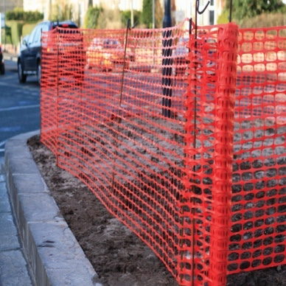
Safety Fence

Definition
A protective barrier installed to prevent access to an erosion prevention measure.

Purpose
To prohibit the undesirable use of an erosion prevention measure by the public.

Conditions Where Practice Applies
Applicable to any control measure or series of measures that can be considered unsafe by virtue of potential for access by the public.

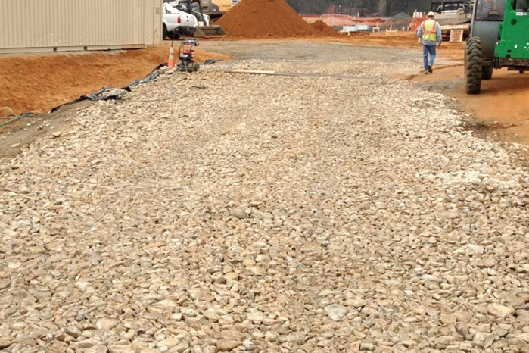
Stabilized Construction Entrance

Definition

A stabilized construction entrance consists of a stabilized aggregate pad with a filter fabric under-liner located at any point where vehicular traffic will be entering or leaving a construction site to or from a public right‐of‐way, street, alley, sidewalk, or parking area.

Purpose
To reduce or eliminate the tracking of sediment onto public rights‐of‐way or streets.

Conditions Where Practice Applies
A stabilized construction entrance is required any place traffic will be leaving a construction site and move directly onto a public road or other paved area.

Construction Road Stabilization

Definition
The temporary stabilization of access roads, subdivision roads, parking areas, and other on‐site vehicle transportation routes with aggregate immediately after grading.

Purpose
To reduce the erosion of temporary roadbeds by construction traffic during wet weather, and to reduce the erosion and subsequent regrading of permanent roadbeds between the time of initial grading and final stabilization.

Conditions Where Practice Applies
Wherever aggregate base roads or parking areas are constructed, whether permanent or temporary, for use by construction traffic.

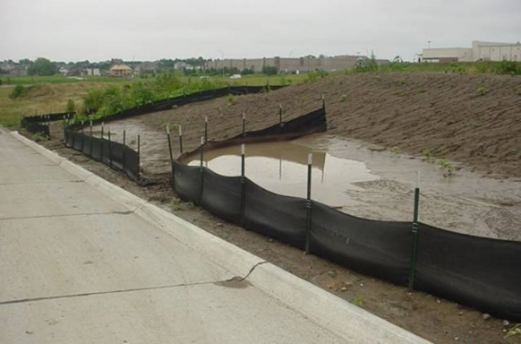
Silt Fence

Definition
An entrenched, temporary sediment barrier consisting of synthetic filter fabric stretched across and attached to supporting posts. A silt fence may have wood or steel posts and may be supported by additional wire fencing.

Purpose
To decrease the velocity of sheet flows and intercept and detain small amounts of sediment from disturbed areas to prevent sediment from leaving a construction site.

Conditions Where Practice Applies
- Below disturbed areas subject to sheet and rill erosion.
- Where the size of the drainage area is no greater than one‐fourth of an ac. per 100 ft. of silt fence length, the maximum slope length behind the barrier is 100 ft., and the maximum slope gradient behind the barrier is 50 percent (2:1). Multiple lines of silt fence spaced 100 ft. apart may be used.
- In areas where rock or other hard surface would not prevent the full and uniform depth anchoring of the barrier.
- Areas where standing water created by the silt fence will not cause a problem.
Silt fences shall not be used as ditch checks. Refer to Section 8.4.25, Wattles, and Section 8.4.9, Check Dams.

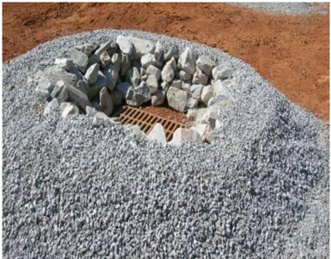
Storm Drain Inlet Protection

Definition
Involves installing a sediment filter or an excavated impounding area around a storm drain drop inlet or curb inlet.

Purpose
To prevent sediment from entering storm drainage systems prior to permanent stabilization of the disturbed area.

Conditions Where Practice Applies
Where the drainage area to an inlet is disturbed, it is not possible to temporarily divert the storm drain outfall into a trapping device and watertight blocking of the inlets is not advisable. This practice is not to be used in place of sediment trapping devices. It may be used in conjunction with storm drain diversion to help prevent siltation of pipes installed with low slope angle. There are five specific types of storm drain inlet protection practices that vary according to their function, location, drainage area, and availability of materials:
1. Excavated Drop Inlet Sediment Trap
2. Silt Fence Drop Inlet Protection
3. Block and Aggregate Drop Inlet Sediment Filter
4. Block and Aggregate Curb Inlet Sediment Filter
5. Filter Sock Curb Inlet Sediment Filter

Culvert Inlet Protection

Definition
Provided by constructing a sediment filter located at the inlet to storm sewer culverts.

Purpose
To prevent sediment from entering, accumulating in, and being transferred by a culvert and associated drainage system prior to permanent stabilization and to prevent erosion at culvert inlets during the phase of a project where elevation and drainage patterns change, causing original control measures to be ineffective or in need of removal.

Conditions Where Practice Applies
Where culvert and associated drainage system is to be made operational prior to permanent stabilization of the disturbed drainage area. Different types of structures are applicable to different conditions.

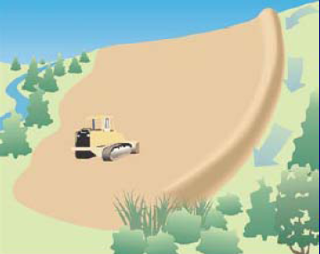
Temporary Diversion Dike

Definition
A temporary ridge of compacted soil constructed at the top or base of a sloping disturbed area.

Purpose
To divert storm runoff from upslope drainage areas away from unprotected disturbed areas and slopes to a stabilized outlet or to divert sediment laden runoff from a disturbed area to a sediment trapping facility such as a sediment trap or sediment basin.

Conditions Where Practice Applies
Wherever stormwater runoff must be temporarily diverted to protect disturbed areas and slopes or retain sediment on‐site during construction. These structures generally have a life expectancy of 18 months or less, which can be prolonged with proper maintenance.

Temporary Fill Diversion

Definition
A channel with a supporting ridge of soil on the lower side, constructed along the top of an active earth fill.

Purpose
To divert storm runoff away from the unprotected slope of the fill to a stabilized outlet or sediment trapping facility.

Conditions Where Practice Applies
Whenever the drainage area at the top of an active earth fill slopes toward the exposed slope, this temporary structure should remain in place for less than one week.

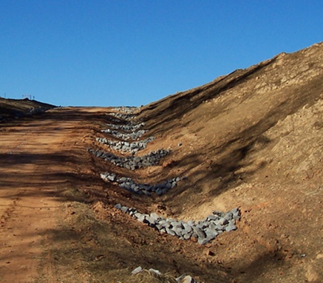
Check Dams

Definition
Small temporary aggregate dams constructed across a swale or drainage ditch.

Purpose
To reduce the velocity of concentrated stormwater flows, thereby reducing erosion of the swale or ditch. This practice also traps sediment generated from adjacent areas or the ditch itself, mainly by ponding of the stormwater runoff. Field experience has shown it to perform more effectively than silt fence in the effort to stabilize wet‐weather ditches.

Conditions Where Practice Applies
Using a combination of aggregate sizes, this practice is limited to use in small open channels that drain 10 ac. or less. It should not be used in a perennial or an intermittent stream as the objective or regulated waterbody. Some specific applications include:
- Temporary ditches or swales that, because of their short length of service, cannot receive a non‐erodible lining but still need protection to reduce erosion.
- Temporary ditches or swales that need protection during the establishment of grass linings.
- An aid in the sediment trapping strategy for a construction site. This practice is not a substitute for major perimeter trapping measures such as a Sediment Trap or a Sediment Basin.

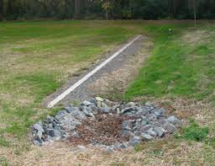
Level Spreader

Definition
An outlet for dikes and diversions consisting of an excavated depression constructed at zero grade across a slope.

Purpose
To convert concentrated runoff to sheet flow and release it uniformly onto areas stabilized by existing vegetation.

Conditions Where Practice Applies
Where there is a need to divert stormwater away from disturbed areas to avoid overstressing erosion prevention measures, and where sediment free storm runoff can be released in sheet flow down a stabilized slope without causing erosion. This practice applies only in those situations where the spreader can be constructed on undisturbed soil and the area below the level lip is uniform with a slope of 10 percent or less and is stabilized by natural vegetation. The runoff water should not be allowed to reconcentrate after release unless it occurs during interception by another measure (such as a permanent pond or detention basin) located below the level spreader.

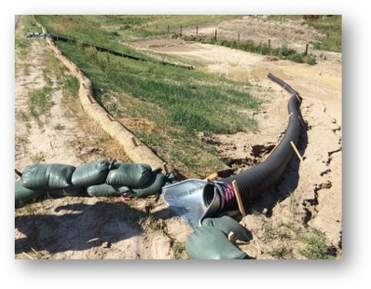
Temporary Slope Drain

Definition
Consists of flexible tubing or conduit extending from the top to the bottom of a cut or fill slope.

Purpose
To temporarily conduct concentrated stormwater runoff safely down the face of a cut or fill slope without causing erosion on or below the slope.

Conditions Where Practice Applies
Temporary slope drains can be used on cut or fill slopes where there is a potential for upslope flows to move over the face of the slope causing erosion and preventing adequate stabilization.

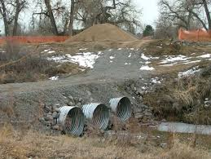
Temporary Vehicular Stream Crossing

Definition
A temporary structural span installed across a flowing watercourse for use by construction traffic. Structures may include bridges, round pipes, pipe arches, or oval pipes.

Purpose
To provide a means for construction traffic to cross flowing steams without damaging the channel or banks and to keep sediment generated by construction traffic out of the watercourse.

Conditions Where Practice Applies
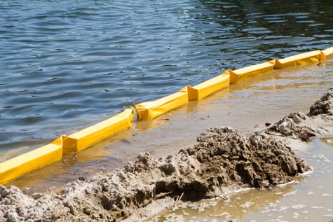
Generally applicable to flowing streams with drainage areas less than 1 sq. mile. Structures that must handle flow from larger drainage areas should be designed using methods that more accurately define the actual hydrologic and hydraulic parameters that will affect the functioning of the structure.

Turbidity Curtain

Definition
A floating geotextile material that minimizes sediment transport from a disturbed area adjacent to or within a body of water.

Purpose
To isolate an active construction area within a lake or pond and to provide sedimentation protection for a watercourse from up‐slope land disturbance or from dredging or filling within the watercourse.

Conditions Where Practice Applies
Applicable to watercourses or lakes where intrusion into the areas by construction activities and subsequent sediment movement is unavoidable. This practice will not reduce the amount of disturbance from work performed in water, but it will minimize the area that is affected.

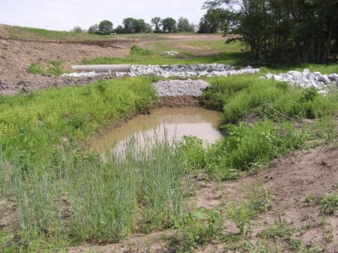
Temporary Sediment Trap

Definition
A temporary ponding area formed by constructing an earthen embankment with an aggregate outlet.

Purpose
To detain sediment‐laden runoff from small disturbed areas long enough to allow most of the sediment to settle out.

Conditions Where Practice Applies
Below disturbed areas where the total contributing area is less than 3 ac. The sediment trap may be constructed either independently or in conjunction with a Temporary Diversion Dike, Section 8.4.7.

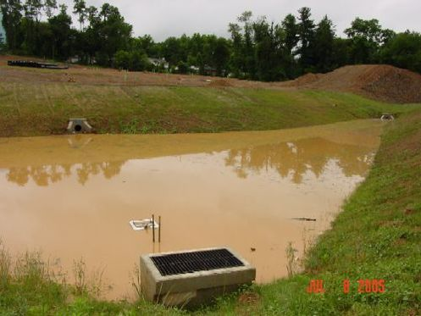
Temporary Sediment Basin

Definition
A temporary barrier or dam with a controlled stormwater release structure formed by constructing an embankment of compacted soil to capture runoff prior to discharging from the project site.

Purpose
To detain sediment‐laden runoff from disturbed areas in “wet” and “dry” storage long enough to allow most of the sediment to settle out.

Conditions Where Practice Applies
Can be constructed below disturbed areas where the total contributing area is equal to or greater than 3 ac. and less than 100 ac. There must be sufficient space and appropriate topography for the construction of a temporary impoundment. It is recommended that a professional in soil erosion and sediment control, professional engineer, or licensed landscape architect design these measures, by virtue of their potential to impound large volumes of water.

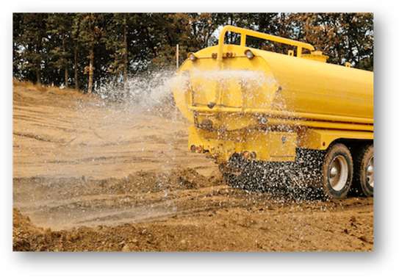
Dust Control

Definition
The practice of reducing surface and air movement of dust during land-disturbing, demolition, and construction activities.

Purpose
To prevent surface and air movement of dust from exposed soil surfaces and to reduce the presence of airborne substances that may present health hazards, traffic safety problems, or harm animal or plant life.

Conditions Where Practice Applies
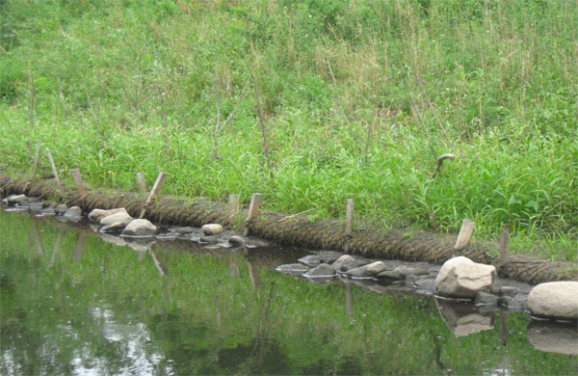
In areas subject to surface and air movement of dust where on‐site and off‐site damage is likely to occur if preventative measures are not taken.

Vegetative Stream Bank Stabilization

Definition
The use of vegetation in stabilizing streambanks.

Purpose
To protect streambanks from the erosive forces of flowing water.

Conditions Where Practice Applies
Along banks in creeks, streams, and rivers subject to erosion from excess runoff. This practice is generally applicable where bank-full flow velocity does not exceed 5 ft. per second and soils are erosion resistant. Above 5 ft. per second, structural measures are generally required.

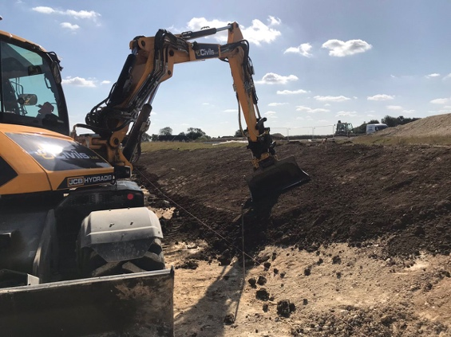
Topsoiling

Definition
Methods of preserving and using the surface layer of undisturbed soil, often enriched in organic matter, to obtain a more desirable planting and growth medium.

Purpose
To provide a suitable growth medium for final site stabilization with vegetation.

Conditions Where Practice Applies
1. Where the preservation or importation of topsoil is determined to be the most effective method of providing a suitable growth medium.
2. Where the subsoil or existing soil presents the following problems:
a. The texture, pH, or nutrient balance of the available soil cannot be modified by reasonable means to provide an adequate growth medium.
b. The soil material is too shallow to provide an adequate root zone and to supply necessary moisture and nutrients for plant growth.
c. The soil contains substances potentially toxic to plant growth.
3. Where high‐quality turf is desirable to withstand intense use or meet aesthetic requirements.
4. Where ornamental plants will be established.
5. Only on slopes that are 2:1 or flatter unless other measures are taken to prevent erosion and sloughing.

Temporary Seeding

Definition
The establishment of temporary vegetative cover on disturbed areas by seeding with appropriate rapidly growing annual plants.

Purpose
To reduce erosion and sedimentation by stabilizing disturbed areas that will not be brought to final grade for a period of 30 days or more, reduce damage from sediment and runoff to downstream or off‐site areas, and provide protection to bare soils exposed during construction until permanent vegetation or other erosion prevention measures can be established.

Conditions Where Practice Applies
Where exposed soil surfaces are not to be fine graded for periods longer than 14 days. Such areas include denuded areas, soil stockpiles, dikes, dams, sides of sediment basins, temporary road banks, etc. A permanent vegetative cover shall be applied to areas that will be left dormant for a period of more than 1 year.

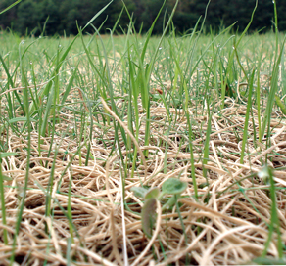
Permanent Seeding

Definition
The establishment of perennial cover on disturbed areas by planting seed.

Purpose
To reduce erosion and sediment yield from disturbed areas, to permanently stabilize disturbed areas in a manner that is economical, is adaptable to site conditions, and allows selection of the most appropriate plant materials, to improve wildlife habitat and to enhance natural beauty.

Conditions Where Practice Applies
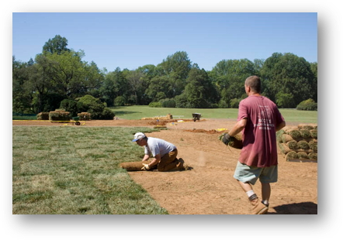
Disturbed areas where permanent, long‐lived vegetative cover is needed to stabilize the soil and rough‐graded areas that will not be brought to final grade for a year or more.

Sodding

Definition
Used to stabilize fine‐graded disturbed areas by establishing permanent grass stands with sod.

Purpose
To establish permanent turf immediately, to prevent erosion and damage from sediment and runoff by stabilizing the soil surface, to reduce the production of dust and mud associated with bare soil surfaces, to stabilize drainageways where concentrated overland flow will occur, and to use as a filtering device for sediments in areas prior to achieving permanent stabilization.

Conditions Where Practice Applies
Disturbed areas that require immediate vegetative cover, or where sodding is preferred to other means of grass establishment. Locations particularly suited to stabilization with sod are waterways carrying intermittent flow, areas around drop inlets or in grassed swales, and residential or commercial lawns where quick use or aesthetics are factors.

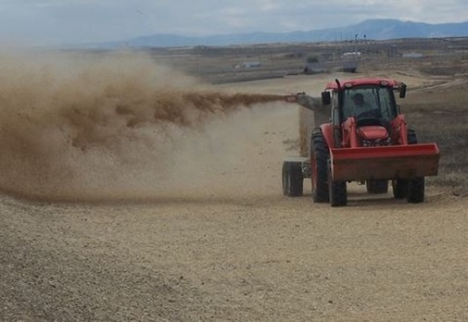
Mulching

Definition
The application of plant residues or other suitable materials to the soil surface. Mulching materials include straw or hay, wood cellulose fiber, corn stalks, wood chips, grass, or aggregate.

Purpose
To prevent erosion by protecting the soil surface from raindrop impact, reducing the velocity of overland flow, and improving infiltration of runoff. Mulching is most effective when used in conjunction with vegetation. Mulch helps foster the growth of soil stabilizing vegetation by holding seeds, fertilizers, and topsoil in place, retaining moisture, and providing insulation against extreme heat and cold.

Conditions Where Practice Applies
Used any time protection of the soil surface is desired, particularly on steep slopes and critical areas such as near waterways. Used in conjunction with seeding to establish vegetation in areas where vegetation is difficult to establish or by itself to provide temporary protection of the soil surface.

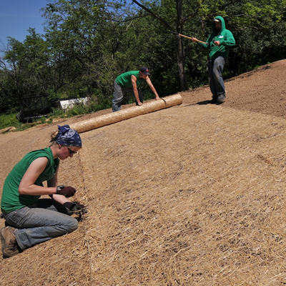
Soil Stabilization Blankets and Matting

Definition
Involve the installation of a protective covering (blanket) or a soil stabilization mat on a prepared surface, slope, channel, or shoreline.

Purpose
To stabilize soil, to protect disturbed soil from erosive forces, to increase infiltration, and/or to conserve soil moisture to promote establishment of vegetation.

Conditions Where Practice Applies
- Slopes and disturbed soils where mulch would have to be anchored and other methods such as crimping or tackifying are not feasible and or adequate.
- Short steep slopes (generally 3:1 or steeper) or slopes where concentrated flows exist or where highly erodible soils are present.
- Locations where seeding is likely to be too slow in providing adequate protective cover.
- Critical slopes adjacent to sensitive areas, such as streams, wetlands, shorelines, and existing development.
- Vegetated channels where the velocity of design flow/concentrated flow exceeds “allowable” velocity.
- Areas prone to sloughing of topsoil.
- Seedbed areas that require thermal consistency and moisture retention.
- Streambanks where moving water is likely to wash out new plantings.
- Areas where the forces of wind prevent standard mulching practices from remaining in place until vegetation becomes established.
- Slope areas where underground springs are present and discharging to the surface.

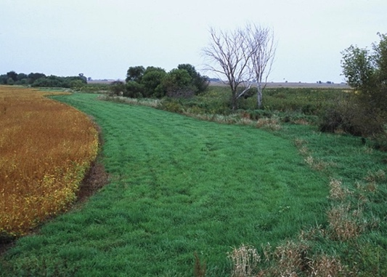
Preserving Natural Vegetation

Definition
The practice of identifying and preserving well‐established existing vegetation areas by prohibiting land-disturbing activity.

Purpose
To maintain existing stabilized ground surface and slopes to reduce erosion potential. To act to filter stormwater runoff and reduce runoff volume, improving runoff water quality and helping to reduce downstream flooding potential.

Conditions Where Practice Applies
In areas where vegetation exists as a predevelopment condition of the site. Especially beneficial for floodplains, wetlands, stream banks, and steep slopes. In areas where erosion prevention measures are difficult to establish, install, or maintain; in areas planned for later phased construction activity; and in areas where no construction activity will occur.

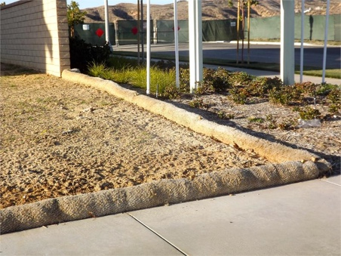
Wattles

Definition
Tube‐shaped erosion prevention devices filled with straw, flax, rice, coconut fiber, or compost material. Also called fiber logs or fiber rolls. Rolls are wrapped in UV‐degradable polypropylene netting or 100‐percent biodegradable material, depending on longevity requirements.

Purpose
To act as a temporary erosion and sediment control barrier. To help slow, filter, and spread overland flows, which, in turn, reduce erosion and minimize rill and gully development. To improve receiving water quality by filtering runoff and capturing sediments. The effects of long or steep slopes can be addressed with wattles installed in combination with straw mulch, erosion prevention blankets, hydraulic mulches, or soil stabilization blankets and matting for slope stabilization.

Conditions Where Practice Applies
In areas of low shear stress. Along sidewalks to prevent sediment from bare lots from washing onto sidewalks and streets. Placed in front of drain inlets to prevent sediment from entering the stormwater system.

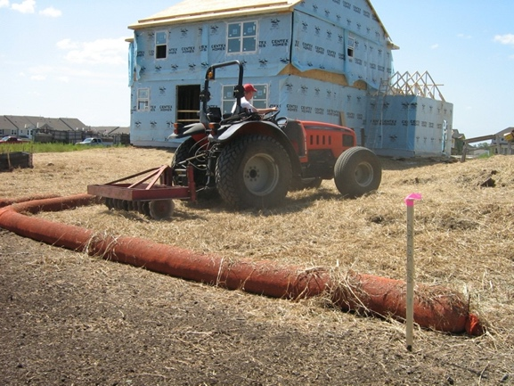
Compost Socks

Definition
A mesh tube filled with composted material that is placed perpendicular to sheet flow runoff to prevent erosion and retain sediment in disturbed areas.

Purpose
To provide a three‐dimensional filter that retains sediment and other soluble pollutants while allowing filtered water to continue to flow on and around construction sites.

Conditions Where Practice Applies
In disturbed areas where unconcentrated stormwater runoff occurs. Compost socks can be used on a steeper slope application if they are spaced closely or used in combination with other BMPs.
Where drainage areas of 0.25 ac. per 100 ft. of compost sock are not exceeded and where flow does not exceed one cu. ft. per second but should not be used in close proximity to a body of water.
Compost socks are typically spaced along the length of the slope as follows (CalTRANS, 2012):
1. 10 ft. on center for slopes steeper than 2:1 (horizontal:vertical)
2. 15 ft. on center for slopes from 2:1 to 4:1 (horizontal:vertical)
3. 20 ft. on center for slopes from 4:1 to 10:1 (horizontal:vertical)
4. 50 ft. on center for slopes flatter than 10:1 (horizontal:vertical)
Compost sock(s) can be used:
1. For perimeter sediment control,
2. On compacted or frozen soils,
3. On slopes up to 2:1 (horizontal:vertical),
4. In sensitive environmental areas where disruption of vegetated root systems or of wildlife migration should be avoided (US EPA, 2012.)

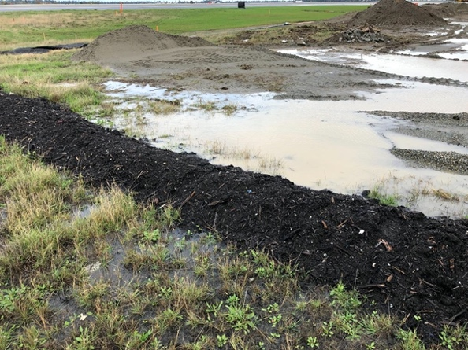
Compost Berm

Definition
A dike, trapezoidal in cross section, composed of compost.

Purpose
Placed perpendicular to sheet flow runoff to prevent erosion and retain sediment in disturbed areas.

Conditions Where Practice Applies
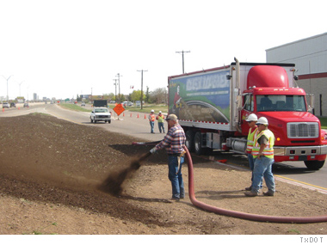
On construction sites with relatively small drainage areas, with slopes up to 2:1 (horizontal:vertical). In steeper slope applications, compost berms can be stacked behind each other along the slope or used in combination with other BMPs. Do not install near water or storm inlet.

Compost Blanket

Definition
A layer of loosely applied compost or composted material placed on disturbed areas to prevent erosion and retain sediment.

Purpose
To assist in intercepting precipitation and increase infiltration and evapotranspiration of water. To act as a buffer to absorb rainfall energy, thereby reducing soil compaction and erosion while maintaining soil permeability until temporary or permanent vegetation has established.

Conditions Where Practice Applies
1. Where land-disturbing activities have ceased to cover open ground and prevent erosion from precipitation.
2. As a means of temporary ground cover to absorb rainfall while temporary and/or permanent vegetation is being established.

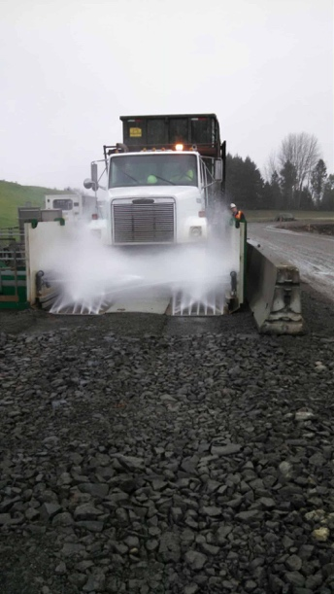
Wheel Wash Area

Definition
A designated area to wash vehicular or equipment wheels to prevent the transfer of mud, dust, or contaminants from leaving a construction site.

Purpose
To reduce or eliminate the tracking of sediment onto streets or other impervious areas thereby reducing the opportunity for sediment to enter storm systems and waterways.

Conditions Where Practice Applies
Whenever construction entrance road stabilization (refer to Section 8.4.2) activities do not prevent the tracking of construction site mud, dust, or contaminants onto a public road or other paved area.

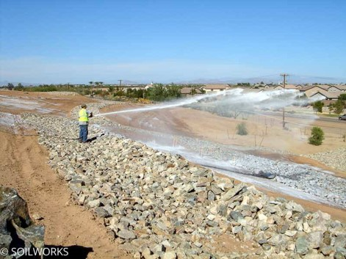
Soil Binders

Definition
Emulsion materials applied to exposed soil surfaces to penetrate the top soil and bind the soil particles together.

Purpose
To temporarily stabilize soils and prevent water and wind erosion of exposed soils at construction sites.

Conditions Where Practice Applies
Sprayed onto disturbed areas that require short‐term protection. Typically used in areas where vegetation cannot be established, in areas where vegetation is not desired (such as soil stockpiles), or are used prior to establishment of vegetation. Often used in combination with other vegetative or perimeter BMPs to enhance erosion and sediment control.

Good Housekeeping Best Management Practices
Using the following BMPs will set the minimum criteria for control practices used within a SWPPP. Using the following guidelines in conjunction with the minimum standards outlined in previous sections will allow the designer of the SWPPP greater flexibility in selecting control practices, while complying with the requirements necessary for City ordinance requirements and State Construction General Permit requirements.

Construction Scheduling and Sequencing

Description and Purpose
Construction scheduling and sequencing is the development of a written plan that includes sequencing of construction activities. The schedule should include the coordination of land‐disturbing activities with the installation of erosion and sediment control measures. The goal is to reduce onsite erosion and offsite sedimentation through scheduling and performing erosion and sediment control measures prior to beginning any land‐disturbing activities.

Conditions Where Practice Applies
All construction projects should have proper sequencing of erosion prevention activities included in the scheduling process, especially during the rainy periods.

Implementation
1. When possible, avoid grading and soil disturbing activities in typically rainy periods.
2. Plan the project and develop the schedule showing every phase of construction. Include seasonal information establishing timeframes when rains would affect soil disturbing activities.
3. Use a schedule to plan sequential activities that support the re-stabilization of disturbed areas as soon as feasible. Sequential activities include closing current trenching prior to initiating more trenching, along with incorporating seeding and vegetation as work progresses.
4. Provide details of each BMP scheduled for implementation and use during the rainy season.
5. Include dates that have non‐stormwater discharge activities such as dewatering, drilling, grinding, mortar mixing, painting, pavement cleaning, saw cutting, etc. (CASQA, 2009)
6. Schedule the stabilization activities for non‐active areas to occur as soon as feasible.
7. Monitor weather forecasts.
8. Keep erosion prevention measures in place year-round to address unseasonal rainfall, wind, and vehicle tracking.
9. Schedule permanent erosion prevention measures to be performed during appropriate seasons and include establishment of vegetation during appropriate planting times.

Inspection and Maintenance
      - Verify work is proceeding according to schedule. Adjust the schedule to address any deviations in progress.
      - Maintain sediment trapping devices to keep them operational throughout the year.
      - Follow the construction sequence throughout the project and modify the schedule before any changes in construction activities are executed. Update the schedule if a site inspection indicates the need for additional erosion and sediment control.

Sanitary Waste Management

Description and Purpose
Proper sanitary waste management prevents the discharge of pollutants to stormwater from sanitary waste by providing convenient, well‐maintained facilities, and arranging for regular service and disposal.

Conditions Where Practice Applies
Sanitary waste management practices are suitable for use at all construction sites that use temporary or portable sanitary waste systems.

Implementation
1. Only contract with a supplier of temporary sanitary waste facilities that disposes of or treats the waste in accordance with state and local requirements.
2. Locate temporary sanitary facilities away from drainage facilities, watercourses, traffic circulation, and in a convenient location.
3. When subjected to high winds or risk of high winds, secure temporary sanitary facilities to prevent overturning.
4. Do not discharge or bury wastewater within the project site.
5. Maintain sanitary facilities in good working order by a licensed service.
6. Arrange regular waste collection by a licensed hauler before facilities overflow.

Education
1. Employees, subcontractors, and suppliers will be educated on sanitary waste storage, disposal procedures, and potential dangers to humans and the environment from sanitary wastes. Maintain sediment trapping devices to keep them in operational conditions throughout the year.
2. A continuing education program will indoctrinate new employees.

Inspection and Maintenance
1. Inspect and verify that temporary sanitary facilities are in place before the commencement of construction activities. While construction activities are under way, inspect weekly.
2. Arrange for regular waste collection.
3. If high winds are expected, secure portable sanitary facilities with spikes or weighed down to prevent overturning.

Solid Waste Management

Description and Purpose
Solid waste management procedures and practices have been designed to prevent or reduce the discharge of pollutants to stormwater from solid or construction waste by providing designated waste collection containers, arranging for regular disposal, and training employees and subcontractors.

Conditions Where Practice Applies
1. Solid waste generated from trees and shrubs removed during land clearing, demolition of existing structures (rubble), and building construction.
2. Scrap or surplus construction wastes and building materials including scrap metals, rubber, plastic, glass pieces, packaging materials, and masonry products.
3. Domestic wastes including food containers such as beverage cans, coffee cups, paper bags, plastic wrappers, and cigarettes.

Implementation
The following steps will be done to keep a clean site and reduce stormwater pollution:
1. Use only watertight dumpsters onsite.
2. Provide an adequate number of containers with lids or covers to keep rain out and to prevent loss of wastes when it is windy.
3. Locate waste containers with liquid in a covered area or provide secondary containment.
4. Collect site litter regularly, especially during rainy and windy conditions.
5. Arrange for regular waste collection before containers overflow.
6. Clean up immediately if a container does spill.

Education
1. Prohibit littering by employees, subcontractors, and visitors.
2. Dumpsters will be located at least 50 ft. from drainage facilities and watercourses and will not be in areas prone to flooding or ponding.
3. The contractor’s superintendent will oversee and enforce proper solid waste management procedures and practices.
4. The contractor’s superintendent will instruct employees and subcontractors on identification of solid waste and hazardous waste.
5. The contractor’s superintendent will require that employees and subcontractors follow solid waste handling and storage procedures.
6. The contractor’s superintendent will make sure that toxic liquid wastes (used oils, solvents, and paints) and chemicals (acids, pesticides, additives, curing compounds) are not disposed of in dumpsters designated for construction debris.

Inspection and Maintenance
- The contractor’s superintendent will verify that the dumpster is in before the commencement of associated activities. While activities associated with the BMP are under way, inspect weekly to verify continued BMP implementation.
- The contractor’s superintendent will inspect the construction dumpster’s area regularly.
- The contractor’s superintendent will arrange for regular waste collection.

Material Delivery and Storage

Description and Purpose
Prevent, reduce, or eliminate the discharge of pollutants from material delivery and storage to the stormwater system, streams, or lakes by storing materials in specifically designated areas, installing secondary containment, conducting regular inspections, minimizing the storage of hazardous materials onsite, and training employees and subcontractors.

Conditions Where Practice Applies
These procedures will be used at all construction sites with delivery and storage of erodible, hazardous, oil based, or other polluting materials.

Implementation
The following steps will be taken to minimize risk.

Deliveries
- Deliveries will be located away from traffic.
- Material delivered and stored will be located near the site entrances (lot level near proposed drive way) and away from area or curb inlets, steams, or waterways.
- If possible, delivery areas will be in locations that are to be paved.

Storage
- Temporary storage will be located away from traffic.
- An up‐to‐date inventory of all stored material will be kept.
- Chemicals, drums, or bagged material will be on a pallet, inside a secondary containment (earthen dike, horse trough, or wading pool for non‐reactive materials).
- Chemicals will be kept in their original containers.
- Storage sites shall be well marked and located away from drainage courses and systems. In no case should any liquid storage drum, tank, or other vessel (including portable toilets) be stored over storm drains.

Practices
- An ample supply of appropriate spill cleanup material will be kept near storage areas and be accessible.
- Drummed, barreled, or bagged materials will be indoors within existing structures when available.
- Provide secondary containment for liquid storage areas. Containment can include any or all of the following:
a. Covers or canopies
b. Reverse grading
c. Area berms to contain flows
d. Drain pans or drop cloths to catch spills leaks when removing or changing fluids
e. Spill control structures
- A temporary containment facility will:
a. Be designed to accommodate all pollutants amounting to or exceeding a volume of 55 gallons.
b. Be designed to provide for a spill of 10 percent of the total stored, or 100 percent of the capacity of the largest container, whichever is greater.
c. Be designed so that material used to contain a spill should be impervious to the stored material for a minimum contact time of 72 hrs.
d. Be maintained free of spills or accumulated rainfall.
e. Have space between the stored material and access for emergency response.
f. Not store incompatible materials (i.e., ammonia and chlorine) in the same containment.
g. Drums, barrels, or bags stored outdoors will be tarped during non‐working hours.
- Stockpiles will be located a minimum of 50 ft. from concentrated flows in stormwater, drainage courses and unprotected inlets (area or curb)
a. Active stockpiles will be protected in accordance with the following practices:
    - Runoff will be controlled using berms, dikes, fiber rolls, silt fence or other appropriate controls.
b. Inactive stockpiles will be protected in accordance with the following practices:
i. Stockpiles will be stabilized with vegetation combines with erosion control BMPs, or tarped.
ii. Runoff will be controlled using berms, dikes, fiber rolls, silt fence or other controls.

Education
Employees, subcontractors, and suppliers will be educated on delivery and storage procedures and their responsibilities.

Inspection and Maintenance
- Inspections will be conducted to verify that all measures are in place and functioning.
- Repairs and/or replacement of controls and covers as needed.

Street Cleaning/Sweeping

Description and Purpose
Street cleaning and maintenance includes the use of front‐end loaders, shovels, and sweepers to remove tracked sediment from the streets and paved surfaces. Street cleaning prevents sediment from entering storm drains and loading sediment basins and /or receiving streams.

Conditions Where Practice Applies
Street cleaning will be done anywhere sediment is tracked from a site onto a public or private paved street or surface, typically at points of entry. Flushing sediment off the surface into the storm system will never be an acceptable practice.

Implementation
The following steps will be taken to keep the streets clean:
- Access points will be limited and controlled; this allows cleaning efforts to be focused and effective.
- Entrance points will be evaluated daily for track‐out.
- Visible sediment tracking will be cleaned or swept daily.
- Kick brooms or dry sweeping will not be used; these spread dirt and generate dust.
- If sediment is not mixed with debris or trash, it will be incorporated back into the project site.

Education
- Employees, subcontractors, and suppliers will be educated on track‐out and street cleaning procedures, and their responsibilities.
- A continuing education program will indoctrinate new employees.

Inspection and Maintenance
The following steps will be taken:
- Evaluate access points daily for sediment tracking.
- When tracked or spilled sediment is found on paved surfaces, it will be removed daily. During times of heavy track‐out, such as during rains, cleaning may be done several times throughout the day.
- Unknown spills or objects will not be mixed with the sediment.
- If sediment is mixed with other pollutants, it will be disposed of properly at an authorized landfill.

Vehicle and Equipment Fueling

Description and Purpose
Vehicle equipment fueling procedures and practices are designed to prevent fuel spills and leaks and to reduce or eliminate contamination of stormwater. This will be accomplished by fueling as outlined below, implementing spill controls, training employees, and requiring subcontractors to have personnel trained in proper fueling procedures.

Conditions Where Practice Applies
Fueling management practices are suitable for use at all construction sites that use fueling tanks or fueling truck systems.

Limitations
With the exception of tracked equipment such as bulldozers and large excavators, mobile construction equipment will be transported to designated fueling areas.

Implementation
- Offsite‐fueling stations will be used as much as possible.
- “Topping‐off” of fuel tanks will be discouraged.
- Absorbent spill cleanup materials and spill kits will be available in fueling areas or on fueling trucks and will be disposed of properly after use.
- Drip pans or absorbent pads will be used during fueling, unless the fueling is performed over an impermeable surface in a dedicated fueling area.
- Absorbent materials will be used on small spills. Spills will not be hosed down or buried. Used adsorbent materials will be removed promptly and disposed of properly.
- Fueling will take place in areas protected from stormwater run‐on and runoff and will be located at least 50 ft. away from downstream drainage facilities and watercourses. Designated fueling areas will be identified in the SWPPP.
- Protect fueling areas with berms or dikes to prevent run‐on, runoff, and to contain spills.
- Nozzles used in fueling will be equipped with an automatic shutoff to control drips. Fueling operations will not be left unattended.
- All requirements will be observed for any stationary above ground storage tanks.

Education
- Employees, subcontractors, and suppliers will be educated on vehicle equipment fueling, spill cleanup, disposal procedures, and the potential dangers to the environment.
- A continuing education program will indoctrinate new employees.

Inspection and Maintenance
- Vehicles and equipment will be routinely inspected for leaks. Leaks will be repaired immediately, or problem vehicles or equipment will be removed from the project site.
- An ample supply of spill cleanup materials will be available. All fuel tanks must have secondary containment.
- Spills will be cleaned up immediately, and contaminated soil and cleanup materials will be properly disposed of. If mobile fueling operation is used, supplier will have spill equipment and procedures on the truck. If stationary fuel storage is used, the Site Manager will have the equipment and procedures onsite.

Concrete Washout

Description and Purpose
A concrete washout is an area used to contain concrete and liquids resulting from cleaning of equipment used to transport and place cementitious material. The purpose of a concrete washout area is to capture and consolidate cementitious liquids and to prevent migration of the material to surface water and groundwater as to prevent environmental and human health impacts. In addition, concrete washout areas make it possible to recycle the collected liquids and solids for reuse.

Conditions Where Practice Applies
Concrete washouts should be used at all sites where equipment used to deliver, mix, or place cementitious material (including concrete, mortar, plaster, stucco, grout, or similar material) is being used and subsequently cleaned/washed onsite. Washed equipment can include, but is not limited to, concrete truck drums and chutes, hoppers, wheelbarrows, and hand tools.

Design Criteria
- The concrete washout area should meet all local, state, and federal stormwater quality requirements.
- The use of the washout facility should be temporary and shall be regularly monitored for capacity. The facility is to be designed with sufficient size and quantity as to contain all liquids generated by washout operations.
- Concrete washouts should be placed near a location where concrete is being placed, in an accessible and convenient location for concrete trucks and equipment. On larger construction sites, multiple concrete washouts may be required. Signage should be used to indicate the location of the concrete washout(s). Ingress/egress to these locations shall be maintained.
- Large washout facilities shall be constructed with stabilized construction entrances per Section 8.4.2. If applicable, construction entrances shall be graded such that water generated on the stabilized entrance shall flow toward the washout facility.
- The washout shall not be located within 50 ft. of storm drains, open ditches/swales, or waterbodies.
- Concrete washouts can be:
  - Lined excavated pits in the ground or aboveground lined holding areas constructed of berms, sandbags, or straw bales
  - Commercially manufactured prefabricated containers

Construction Guidelines
- Below grade holding areas shall:
  - Be lined with an impermeable liner with a minimum thickness of 10‐mil.
  - Be designed to contain all liquids generated by washout operations.
  - Include a soil base free of rocks and sharp objects that could compromise the integrity of the liner.
  - Have a minimum of 10 ft. by 10 ft. flat area at the bottom and a minimum of 3 ft. high sloped embankments.
- Above‐ground holding areas shall:
  - Be lined with an impermeable liner with a minimum thickness of 10‐mil.
  - Be designed to contain all liquids generated by washout operations.
  - Include a soil base free of rocks and sharp objects that could compromise the integrity of the liner.
  - Hay bales shall be used along the perimeter of the facility. The plastic lining shall be wrapped over the top of the hay bale and the hay bale and liner shall be properly anchored.
- Commercially manufactured prefabricated containers shall be used and maintained in accordance with manufacturer’s directions. They should be properly sized to accommodate the flows generated by washout operations. Common container types include:
  - Vinyl washout containers
  - Metal washout containers
  - Chute washout boxes
  - Chute washout bucket and pumps
- Concrete washout filters can be used with the intent of recycling washout materials and should be used in conjunction with a containment facility listed above.

Inspection and Maintenance
- Concrete washout areas should be inspected regularly to verify adequate capacity and integrity of the containment. The washout area must be cleaned, or a new washout area be ready for use when the existing washout capacity reaches 75‐percent full. Additionally, the following inspections shall take place weekly at a minimum:
  - Above and below-ground holding areas:
    - Check that the liner is free of punctures, holes, and tears
    - Confirm that the hay bales and liner are adequately anchored.
- For above and below grade storage facilities and other commercially manufactured containment structures:
  - Allow liquids to evaporate or vacuum off excess liquids. Vacuumed liquids shall be treated to remove metals and reduce the pH and then conveyed/delivered to the wastewater treatment plant for treatment or other acceptable means of disposal.
  - Remove hardened solids by breaking up solids as necessary.
  - Dispose of hardened materials to the landfill or recycle.
- If recycling of material is desired, the following may be considered:
  - Cementitious material remaining inside the truck after delivery shall be taken back to the ready-mix plant for reuse in other concrete structures or dumped and allowed to hardened so it can be crushed and recycled as aggregate.
  - When using concrete washout filters, treated wash water can be reused as wash water for subsequent equipment or as material for making new concrete. The aggregates, sands, and fines can be used on the construction site as needed or returned to the ready-mix plant for reuse in new concrete.
  - Hardened concrete can be crushed and reused as a construction material.

SWPPP Inspection and Maintenance Procedures

Inspection and Maintenance Requirements
1. SWPPP plans submitted for approval must include placement of the following statement: “All sediment and erosion control practices will be inspected and documented at least once every 14 calendar days and after any storm event of greater than 0.5 inches of precipitation during any 24-hour period by qualified personnel. Any necessary repairs or cleanup to maintain the effectiveness of the best management practices must be made within 7 days or prior to the next storm event whenever practicable. If implementation before the next storm event is impracticable, the situation must be documented in the inspection report and alternative BMPs must be implemented as soon as possible. Failure to provide current inspection records is a violation of the SWPPP requirements and the person responsible will be subject to penalties, fines. or fees.”
2. Inspections should be conducted by Qualified Personnel who are knowledgeable in the principles and practices of erosion and sediment control. Qualified personnel should possess the technical skills to assess conditions at the construction site that could impact stormwater quality and assess the effectiveness of any erosion and sediment control measures selected.
3. A log of these inspections must be retained with the SWPPP, along with photographs or other supporting information. Any deficiencies must be noted in an inspection report and include any action taken to correct the deficiency. Inspection reports and follow-up documentation regarding violations and associated corrective actions must be submitted to the City.
4. At a minimum, the inspection report must include:
a. The inspection time and date
b. Names and titles of personnel making the inspection
c. Weather information for the period since the last inspection (or since commencement of construction activity if this is the first inspection) including a best estimate using publicly accessible data of the beginning of each storm event, duration of each storm event, approximate amount of rainfall for each storm event (in inches), and whether any discharges occurred
d. Weather information and a description of any discharges occurring at the time of the inspection
e. Location(s) of discharges of sediment or other pollutants from the site
f. Location(s) of BMPs that need to be maintained
g. Location(s) of BMPs that failed to operate as designed or proved inadequate
h. Monitoring results if requested
i. Records of grading activity since last inspection
j. Location(s) where additional BMPs are needed that did not exist at the time of inspection
k. Corrective action that required changes to the SWPPP and the date the plan changes were implemented
5. Record keeping: The permittee must keep copies of the SWPPP, inspection records, copies of all reports required by the permit, and records of all data used to complete the NOI to be covered by the permit for a period of at least three (3) years from the date that permit coverage expires or is terminated. Records should include:
a. A copy of the SWPPP, with any modifications
b. A copy of the NOI and Notice of Termination (NOT) and any stormwater-related correspondence with federal, state, and local regulatory authorities
c. Inspection forms, including the date, place, and time of BMP inspections
d. Names of inspector(s)
e. The date, time, exact location, and a characterization of significant observations, including spills and leaks
f. Records of any non-stormwater discharges
g. BMP maintenance and corrective actions taken at the site (Corrective Action Log)
h. Any documentation and correspondence related to endangered species and historic preservation requirements
i. Date(s) when major land-disturbing (i.e., clearing, grading, and excavating) activities occur in an area
j. Date(s) when construction activities are either temporarily or permanently ceased in an area
k. Date(s) when an area is either temporarily or permanently stabilized

References
- City of Lincoln Public Works and Utilities Department, 2007. Drainage Criteria Manual.
- City of Omaha Environmental Quality Control Division, 2014. Omaha Regional Stormwater Design Manual.
- Mile High Flood District (formerly Urban Drainage and Flood Control District), 2016. Urban Storm Drainage Criteria Manual.

